


Standard XML Reporting
Instructions and Specifications

Version 4.0

Table of Contents

1. Summary 3
2. Conventions used in this document 3
3 Description of XML Nodes 4
3.1 Node “report” 4
Report Type/ 5
3.11 Subnode report_indicators 6
3.2 Node transaction 7
3.3 Node Activity (New in Schema 4.0) 10
3.41 Node t_from_my_client 11
3.42 Node t_from 12
3.51 Node t_to_my_client 14
3.52 Node t_to 15
3.6 Subnode goods_services 16
4. Description Of Common Types Used in the Schema 18
4.11 Type t_account_my_client 18
4.12 Type t_account 21
4.21 Type t_entity_my_client 24
4.22 Type t_entity 26
4.31 Type t_person_my_client 29
4.32 Type t_person 33
4.4 Type t_party 36
Is my Client 37
4.5 Type t_address 38
4.6 Type t_phone 39
4.7 Type t_foreign_currency 41
4.8 Type t_person_identification 42
4.9 Type report_party_type 43
5. Lookup Values 44
5.1 Submission type – goAML Enumeration 44
5.2 Funds type 44
5.3 Account type 44
5.4 Account status type 45
5.5 Identifier type 45
5.6 Transaction Type 45
5.7 Transaction Item Status 46
5.8 Report Code – goAML Enumeration 46
5.9 Contact Type 46
5.10 Communication Type 46
5.11 Entity Legal Form Type 47
5.12 Transaction Item Type 47
5.13 Currencies - Enumeration 47
5.14 Country Codes - Enumeration 52
5.15 Role type of Signatory 58
5.16 Entity person role type 58
5.17 Occupation List 58
5.18 Division Name 60
5.19 District Name 60
5.20 Thana Name 61
5.21 STR INDICATOR 73
6. BUSINESS Validation Rules 74

Summary

The purpose of this specifications document is to provide both the reporting entities and reporting persons with the requirements and conditions for creating compatible XML files using the provided XML- Schema for the different supported report types.

A report file contains the following information which can be represented in the goAML Client after uploading and verifying the XML file.

- Basic information about the report.
- Where does the money come from.
- Who conducted the transaction.
- Where does the money go to.
- Was the transaction related to a property transfer
- Who reported the transaction(s) (Optional)
- What was the reason for the report and which actions have been taken (Optional)
- In multi-party transactions, list of all involved parties and their respective roles in the transactions.

An XML report is linked to one Reporting Entity but may contain multiple transactions. An uploaded report can be from ONE report type.

This document will provide a reference to the schema, nodes and types as well as the lookup tables for enumeration values. (e.g. Country Codes)

Conventions used in this document

The following conventions are used in this document:

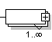 | Required field  Required, 1 to N values
 | Optional field
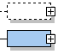 | Optional sub node  Required sub node
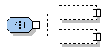 | Optional, but one of the two nodes should be provided
Integer | A 32 bit value
Date time | A date and time value in the following format:  YYYY-MM-DDTHH:MM:SS
 | Sequence to sub nodes

3 Description of XML Nodes

3.1 Node “report”
Basic information about Reporting Entity, reporting date and type of report. It can contain multiple transactions.
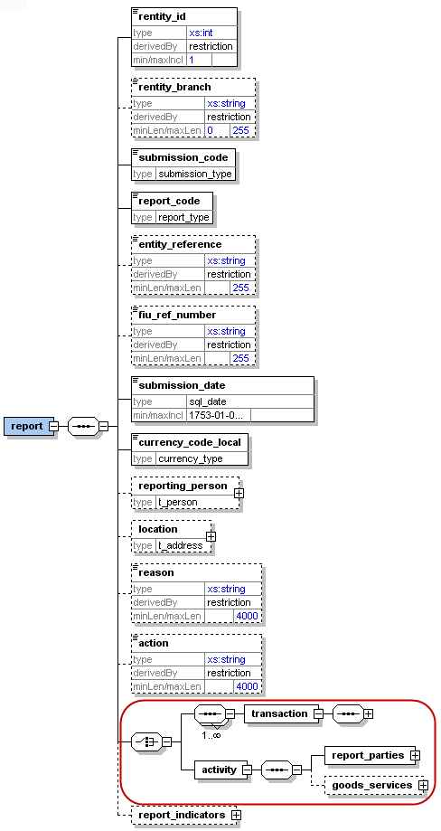
Figure 1: Overview node “report”

Name |  | Description |  | Length |  | Req. |  | Label/Example
rentity_id |  | Reporting Entity number defined by FIU |  | Integer  >= 1 |  | Y |  | 12
rentity_branch |  | Branch of current reporting entity. |  | 255 |  | Y |  | Entity Branch Name-Code/Branch Name of Prime Bank-SBS Code whom reported the transactions (Motijheel Branch-0132)
submission_code |  | Type of submission |  | Enumeration |  | Y |  | See 5.1 Submission type/ For XML reporting always select 'E'
report_code |  | Type of Report(CTR/STR) |  | Enumeration |  | Y |  | Report Type/
entity_reference |  | Entity Code |  | 255 |  | Y |  | Entity Reference/12
fiu_ref_number |  | Optional ref. number to be used as communication channel between the BFIU and the Reporting Entity |  | 255 |  | N |  | FIU Reference No./PBL/HO/CCU/2013/48
submission_date |  | Submission date and time |  | Datetime |  | Y |  | Submission Date/2006-03-25T11:55:00 (System Date)
currency_code_local |  | Local Currency code |  | Type “Currency-type” |  | Y |  | BDT
reporting_person |  | Full details of the report’s reporting person |  | Type “t_person” |  | N |  | Can be forced mandatory in certain report types by using the new goAML feature: “XML Rejection Rules”
Location |  | Describes location of the reported report |  | Type “t_address” |  | Y |  | Address/ Same as “reporting person”
reason |  | Why the report was reported (specially for STRs) |  | 4000 |  | Y |  | Reason / Same as “reporting person”
action |  | Describes action related to the report |  | 4000 |  | N |  | Action Taken/ Same as “reporting person”
 | transaction |  | Transaction information |  | type  transaction |  | Y
 | Activity |  | Involved subjects and items list linked directly to report. |  |  |  | Y
report_indicators |  | List of indicators for the current reports |  | Type “indicator” |  | 0..many |  | See 3.11 Subnode report_indicators
Table 1: Details node “report”

3.11 Subnode report_indicators
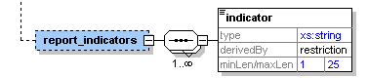

Figure 2: Overview subnode report_indicators

Name | Description | Length | Req. | Label/Example
indicator | Some classification for the report | 25 | Y | STR indicators/ Inconsistent transaction,Reluctant to penalty, etc.  (FIU predefined list of codes)

Table 2: Details subnode report_indicators

3.2 Node transaction
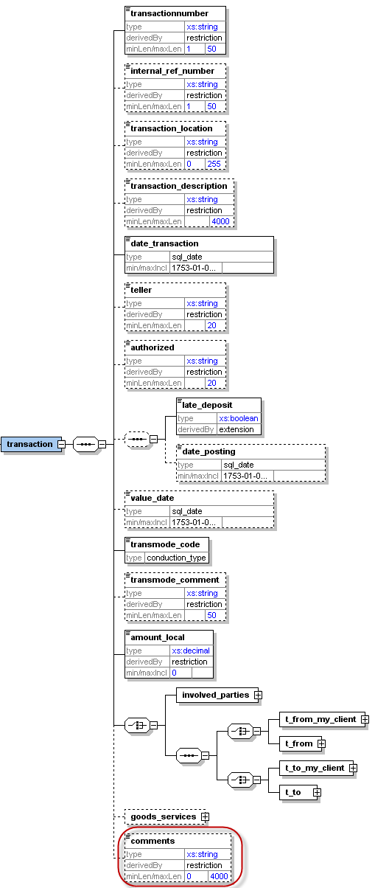

Figure 3: Overview node transaction

Name |  | Description |  | Length |  |  | Req. |  | Label/Example
transactionnumber |  | Unique transaction number for bank transaction |  | 50 |  |  | Y |  | Transaction No./ TRNWEB 2013-04-22 0018
Internal_ref_number |  | Reporting Entity internal transaction reference number |  | 50 |  |  | N |  | Internal Reference Number/ CS02896325
transaction_location |  | Branch/Location where the transaction took place |  | 255 |  |  | Y |  | Transaction Location/Mohakhali Branch
transaction_description |  | Free text field to describe the purpose of the transaction |  | 4000 |  |  | N |  | Description/Cash Deposit
date_transaction |  | Date and time of the transaction |  | DateTime |  |  | Y |  | Transaction Date/2006-03-25T11:55:00
teller |  | Who conducted the transaction |  | 20 |  |  | N |  | Teller/Mr. Rafique
authorized |  | Who authorized the transaction |  | 20 |  |  | N |  | Authorized By/Mr. Nuruzzaman
late_deposit and date_posting are both optional but when setting date_posting, late_deposit becomes mandatory.
3 possible combinations
1. none of the nodes is set
2. only late_deposit is set
3. late_deposit AND date_posting are set
late_deposit |  | Late deposit indicator |  | Boolean |  |  | Y/N |  | Late Deposit/False
date_posting |  | Date of posting (if different from date of transaction) |  | DateTime |  |  | N |  | Date Posting/2006-03-24T19:55:00
value_date |  | Value date |  | DateTime |  |  | N |  | 2006-03-27T00:00:00
transmode_code |  | How the transaction was conducted |  | Enumeration |  |  | Y |  | Transaction Type/See 5.6 Transaction Type
transmode_comment |  | Description if transmode_code is “O” (Other) |  | 50 |  |  | N |  | Transaction Type Comment
amount_local |  | The value of the transaction in local currency |  | Decimal |  |  | Y |  | Amount(In BDT) /100000000
Transaction could be either a bi-party transaction with clear From and To sides, or a multi-party transaction with unlimited list of subjects (Persons, Accounts and Entities) where each has a role in the transaction rather than a clear from or to side.
Bi-Party Transaction
 | One of the nodes t_from_my_client or t_from should be provided. Both CANNOT be present together in a transaction, but one of them should be present.
 | t_from_my_client |  | Specifies where the money came from. If the source is reporting bank’s client, then this node should be provided |  | Subnode |  |  | Y  (one of them) |  | See t_from_my_client
 | t_from |  | Specifies where the money came from |  | Subnode |  |  |  |  | See 3.42 Node t_from
 | One of the nodes t_to_my_client or t_to should be provided. Both CANNOT be present together in a transaction, but one of them should be present.
 | t_to_my_client |  | Specifies where the money went. If the destination is reporting bank’s client, then this node should be provided |  | Subnode |  |  | Y  (one of them) |  | See 3.51 Node t_to_my_client
 | t_to |  | Specifies where the money went. |  | Subnode |  |  |  |  | See 3.52 Node t_to
Multi-Party Transaction
 | This is a new node in schema 3.0. It covers transactions with multi-party involvement covering non-banking transactions. Car dealers for example can report such transactions where more than one subject bought/sold a car, while the car dealer is not reported as part of the transaction but only as the reporting entity. If the transaction is reported in this way, then at least one “Party” node should be reported.
 | party |  | Describes the involved party details |  | Type “t_party” |  |  | Y |  | See 4.4 Type t_party
Goods_services |  | The goods/services linked to the transaction |  |  |  | subnode |  | N |  | See 3.5 3.6 Subnode goods_services
Comments |  | Generic comments field |  |  |  | 4000 |  | N
Table 3: Details node transaction

3.3 Node Activity (New in Schema 4.0)

A new feature of schema 4.0. Reports can now include an activity node to represent an event where a list of subjects and goods are related directly to the report without the need of a transaction.

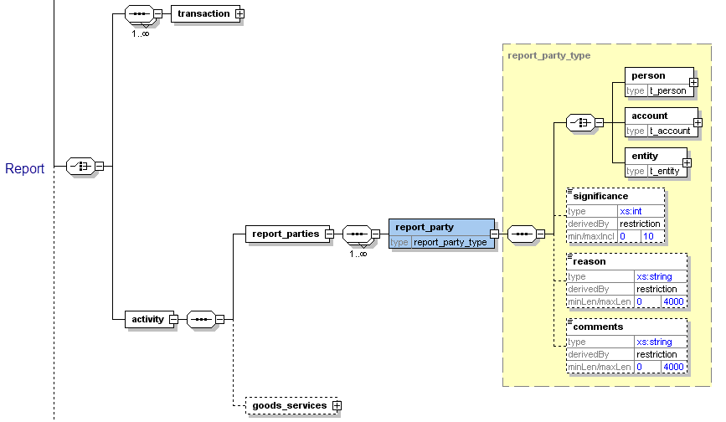

Figure 4: Overview node activity

Name | Description | Length | Req. | Example
report_parties | Represents a collection of involved subjects an involved subject with it’s details |  | Y
report_party | Represents a single involved subject with its details. At least one party should be included. | Type report_party_type | Y | See 4.9 Node report_party_type
goods_service | The standard goods_services node available in previous schemas | Type t_trans_item | N | -

Table 4: Details node transaction

3.41 Node t_from_my_client

This node should be provided if the source side of the transaction is a client of the reporting bank. As on schema 4.0, entity could be a direct party in bi-party transactions
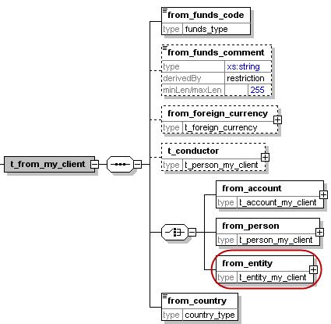

Figure 5: Overview node t_from_my_client

Name | Description | Length | Req. | Label/Example
from_funds_code | Type of funds used in initiating transaction | Enumeration | Y | Funds Type/See 5.2 Funds type.Ex. k
from_funds_comment | Description of funds if any | 255 | N | Funds Comment/
from_foreign_currency | If the transaction is conducted in foreign currency, then specify the foreign currency details. | type  t_foreign_currency | N | Foreign Currency/See 4.7 Type t_foreign_currency
t_conductor | The person performing the transaction. | type  t_person_my_client | N | See 4.31 Type t_person_my_client
from_account | Subnode that holds account information | type t_account_my_client | Y  (one of them only) | See 4.11 Type t_account_my_client
from_person | Subnode that holds “from person” information. | Type  t_person_my_client | Y  (one of them only) | See 4.31 Type t_person_my_client
from_entity  New in Schema 4.0 | Subnode that holds “from entity” information. | Type t_entity_my_client | Y  (one of them only) | See 4.32 Type t_entity_my_client
from_country | Country where transaction was initiated. | Enumeration | Y | See 5.14 Country Codes
Table 5: Details node t_from_my_client

3.42 Node t_from

Source of the transaction. Can be either a person, an account or an entity. In case of a person source, as per Schema 3.0, the conductor could be different from the source person. As per schema 4.0,the entity could be a direct party in bi-party transactions

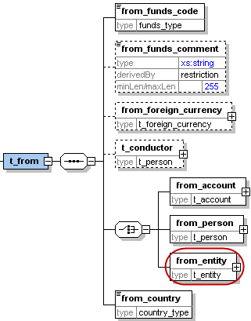
Figure 6: Overview node t_from

Note: Bi-directional transactions are composed of a source and destination. The source and destination may be either a person, an account or an entity (As per schema 4.0). For account deposits, the source is a person and the destination is an account i.e. on t_from side we will have from_person and on the t_to side we will have t_to_account. For account withdrawals, we will have from_account at the t_from side and to_person at the t_to side. For money remittances, we will have person to person transactions i.e. from_person at the t_from side and to_person at the t_to side. The same structure of person to person transactions can be used for any money service type of transaction. For account transfers, we will have account to account transactions i.e., from_account at the t_from side and to_account at the t_to side.

Name | Description | Length | Req. | Label/Example
from_funds_code | Type of funds used in initiating transaction | Enumeration | Y | Funds Type /See 5.2 Funds type Ex. k
from_funds_comment | Description of funds if any | 255 | N | Funds Comment
from_foreign_currency | If the transaction is conducted in foreign currency, then specify the foreign currency details. | type  t_foreign_currency | N | Foreign Currency /See 4.7 Type t_foreign_currency
t_conductor | The person performing the transaction. | type  t_person | N | See 4.32 Type t_person
from_account | Subnode that holds account information | type “t_account | Y  (one of them) | See 4.12 Type t_account
from_person | Subnode that holds “from person” information. | type  “t_person” | Y  (one of them) | See 4.32 Type t_person
from_entity  New in Schema 4.0 | Subnode that holds “from entity” information. | type “t_entity” | Y  (one of them) | See 4.22 Type t_entity
Table 6: Details node t_from

3.51 Node t_to_my_client

This node should be provided if the destination side of the transaction is a client of the reporting bank.

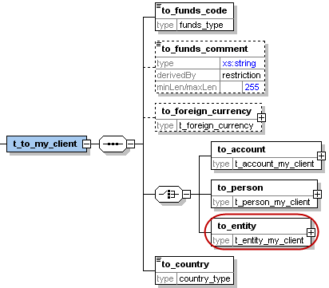

Figure 7: Overview node t_to_my_client

Name | Description | Length | Req. | Label/Example
to_funds_code | Disposition of funds | Enumeration | Y | Funds Type/See 5.2 Funds type Ex. k
to_funds_comment | Description of funds if any | 255 | N | Funds Comment/
to_foreign_currency | If the transaction is conducted in foreign currency, then specify the foreign currency details. | type  t_foreign_currency | N | See 4.7 Type t_foreign_currency
to_account | Subnode that holds account information | type t_account_my_client | Y  (one of them) | See 4.11 Type t_account_my_client
to_person | Subnode that holds person information | type t_person_my_client | Y  (one of them) | See 4.31 Type t_person_my_client
to_entity  New in Schema 4.0 | Subnode that holds “to entity” information. | Type t_entity_my_client | Y  (one of them) | See 4.32 Type t_entity_my_client
to_country | Target country of the transaction | Enumeration | Y | See 5.14 Country Codes
Table 7: Details node t_to_my_client

3.52 Node t_to

Information about the transaction disposition(s) - i.e. where the money went.
t_to can either point to a person or to an account.

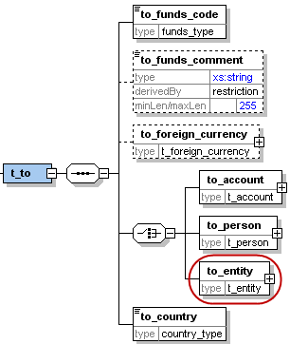

Figure 8: Overview node t_to

Name | Description | Length | Req. | Example
to_funds_code | Disposition of funds | Enumeration | Y | Funds Type/See 5.2 Funds type Ex. k
to_funds_comment | Description of funds if any | 255 | N | Funds Comment
to_foreign_currency | If the transaction is conducted in foreign currency, then specify the foreign currency details. | type  t_foreign_currency | N | See 4.7 Type t_foreign_currency
to_account | Subnode that holds account information | type t_account | Y  (one of them) | See 4.12 Type t_account
to_person | Subnode that holds person information | type t_person | Y  (one of them) | See 4.32 Type t_person
to_entity  New in Schema 4.0 | Subnode that holds “to entity” information. | Type t_entity | Y  (one of them) | See 4.22 Type t_entity
to_country | Target country of the transaction | Enumeration | Y | See 5.14 Country Codes
Table 8: Details node t_to

3.6 Subnode goods_services
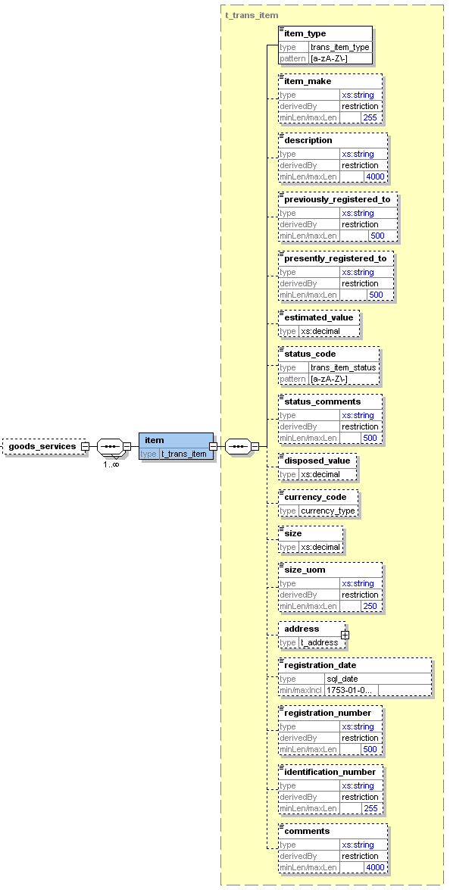

Figure 9: Overview subnode goods_services

Name | Description | Length | Req. | Label/Example
Item_type | Lookup code describes the item type | Type “trans_item_type” | Y | C = Car  L = Land
Item_make | Item Maker | 255 | N | In case of Car for example, BMW
description | Text | 4000 | N | Apartment building
previously_registered_to | Name of previous owner | 500 | N | John Smith
presently_registered_to | Name of current owner | 500 | N | Jane Smith
estimated_value | Estimated value of the property – Used Currency is the one specified in node from_currency | Decimal | N | 250000.00
status_code | Status code | Enumeration | N | See 5.7 Transaction Item Status
status_comments | Status Comments | 500 | N
disposed_value | effective value for property transfer – Used Currency is the one specified in node from_currency | Decimal | N | 500000.00
Currency_code  (New in Schema 3.1) | used to report service conducted in foreign currency | Enumeration | N | See 5.13 Currencies
Size | Size of the property – in unit specified in node size_uom | Decimal | N | 150
size_uom | Unit of measurement | 250 | N | Square meters
Address | Address of the property | type t_address | N | 4.5 Type t_address
registration_date | Official registration date | DateTime | N | 2001-12-17T09:30:47
registration_number | Official registration number | 500 | N | Car VIN Number
Identification_number | Any number that can identify the item | 255 | N | Car Plate Number
Comments | Additional comments | 4000 | N
Table 9: Details subnode goods_services

Description Of Common Types Used in the Schema

4.11 Type t_account_my_client
The structure of this type is similar to that of type t_account, with some added restrictions i.e. some nodes which are not mandatory in t_account may be mandatory in t_account_my_client.
These restrictions are defined by the local FIU. The logic here is that whenever the involved account or person is the client of the reporting entity, more details may be demanded on the client, and the reporting entity must have the information as part of the adherence to the “Know Your Customer” (KYC) philosophy of compliance.
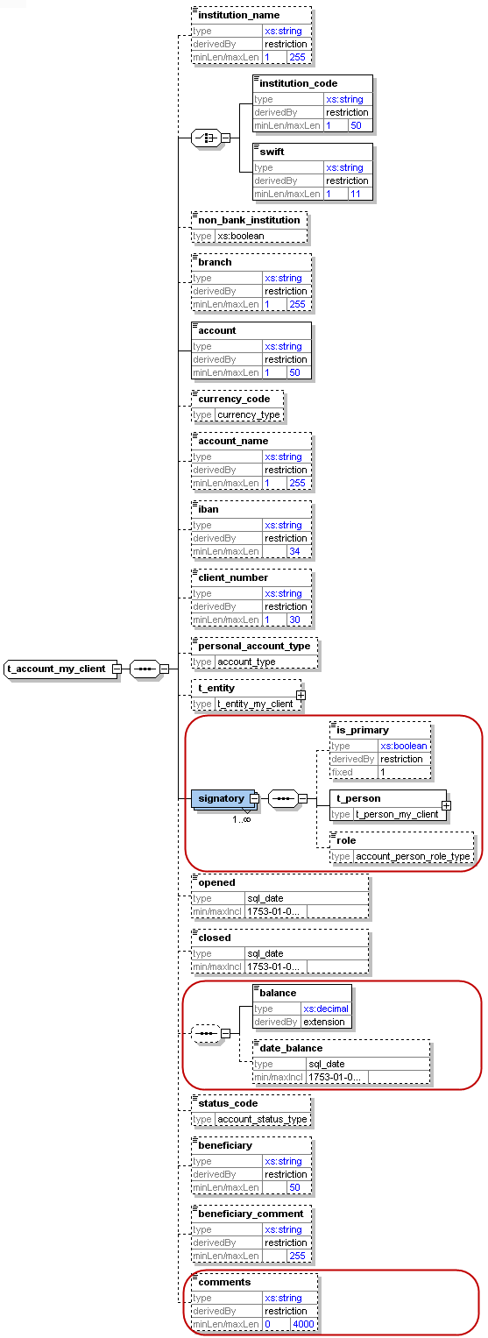

Figure 10: Overview type t_account_my_client

Name | Description | Length | Req. | Label/Example
Instituation_name | The name of the Bank | 255 | Y | InstitutionName/The Trust Bank Ltd
institution_code | Institution code | 50 | Y  (one of them) | Institution Code/ 0112
swift | SWIFT code according to ISO 9362 | 11 | Y  (one of them) | Swift/JANBBDD
Non_banking_institution | A flag to cover cases where the account belongs to non-banking institution | Boolean | N | Non Bank Institution/ Insurance company
Branch  (enlarged in vesion. 3.1 to 255 chars) | Branch Name - code | 255 | Y | Branch Name-Code/Motijheel-0123
Account  (enlarged in vesion. 3.1 to 50 chars) | Account number | 50 | Y | Account No/31032027088
currency_code | Currency the account is kept in | Enumeration | Y | Account Currency/See 5.13 Currencies(Taka)
account_name  (enlarged in 3.1 to 255 chars) | This is a free text field used to “Label” the account, for example a saving book account with anonymous owner, or an Entity account dedicated to Invoices, etc. | 255 | Y | Account Title/Magpie Textiles Ltd
iban | IBAN | 34 | N | IBAN /LT601010012345678901
client_number | Client number | 30 | Y | 31032027088
personal_account_type | Account Type | Enumeration | Y | Account Type/See 5.3 Account type
t_entity | Business entity owning the account | type  t_entity | N | See 4.22 Type t_entity
signatory | Person(s) with access to the account. | Subnode (can repeated to specify multiple signatories). Note that the node t_person is of type t_person_my_client | Y | -
is_primary | Identifies the primary account holder. Only one signatory may be marked as is_primary. Has to be ‘true’ when node is set. | fixed = 1 | N
t_person | Subnode holding detailed information about the signatory. Mandatory for signatories in the XML report. | type  t_person_my_client | Y | See 4.31 Type t_person_my_client
role  (New in Schema 4.0) | Subnode holding enumeration about the role of current signatory with the account. report. | type  “account_person_role_type” | N | See 5.154.31 Type t_person_my_client
opened | Date account opened | DateTime | Y | Account Opened on/2006-03-24T19:55:00
closed | Date account closed | DateTime | N | Closed on/2006-03-24T19:55:00
balance | The account balance after the transaction was conducted. | Decimal | Y | Account Balance/5000.50
date_balance  (New in Schema 4.0) | A date to specify the date of the reported balance. Application will show balance history | Date | N | Date of Balance/2006-03-24T19:55:00
status_code | Account status when transaction was initiated | Enumeration | Y | Account Status/See 5.4 Account status type
beneficiary | Ultimate beneficiary of the account | 50 | Y | Beneficiary/Ella Machera
beneficiary_comment | Any special remark on the beneficiary | 255 | N | Beneficiary Comment/
comments | Generic comments elements | 4000 | N | Comments /

Table 10: Details type t_account_my_client

4.12 Type t_account
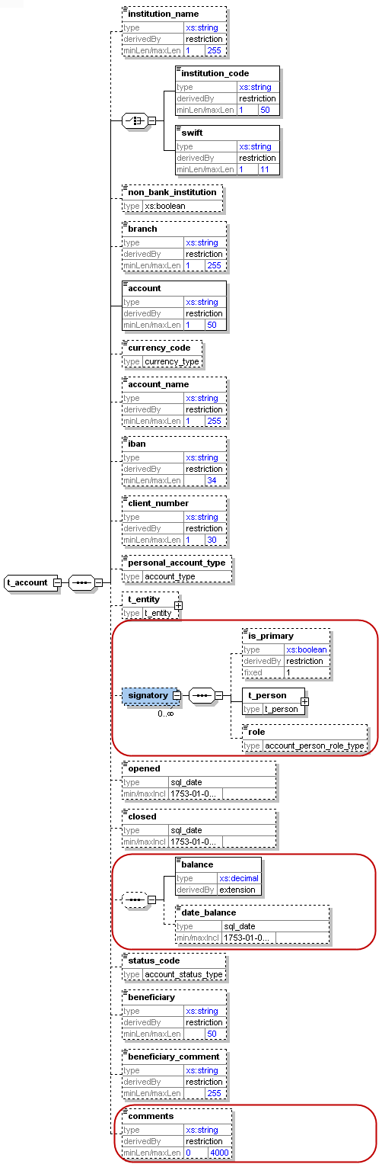

Figure 4: Overview type t_account

Name | Description | Length | Req. | Label/Example
Instituation_name  (New in Schema 3.0) | The name of the Bank | 255 | N | InstitutionName/The Trust Bank Ltd
institution_code | Institution code issued by FIU | 50 | Y  (one of them) | Institution Code/
swift | SWIFT code according to ISO 9362 | 11 | Y  (one of them) | Swift/JANBBDD
Non_banking_institution  (New is Schema 3.0) | A flag to cover cases where the account belongs to non-banking institution | Boolean | N | Non bank Institution/Insurance company
Branch  (Increased to 255 chars in Schema 3.1) | Branch code or name | 255 | N | Branch Name-Code/Motijheel-0123
Account  (Increased to 50 chars in Schema 3.1) | Account number | 50 | Y | Account No/31032027088
currency_code | Currency the account is kept in | Enumeration | N | Account Currency/See 5.13 Currencies(Taka)
account_name  (Increased to 255 chars in Schema 3.1) | This is a free text field used to “Label” the account; for example a saving book account with anonymous owner, or an Entity account dedicated to Invoices, etc. | 255 | N | Account Title/Magpie Textiles Ltd
iban | IBAN | 34 | N | IBAN /LT601010012345678901
client_number | Client number | 30 | N | 31032027088
personal_account_type | Account Type | Enumeration | N | Account Type/See 5.3 Account type
t_entity | Business entity owning the account | type  t_entity | N | See 4.22 Type t_entity
signatory | Person(s) with access to the account. | Subnode (can be repeated to specify multiple signatories).  Note that the node t_person is of type t_person | N | -
is_primary | Identifies the primary account holder. Only one signatory may be marked as is_primary. Has to be ‘true’ when node is set. | fixed = 1 | N
t_person | Subnode holding detailed information about the signatory. Mandatory for signatories in the XML report. | type  t_person | Y | See 4.31 Type t_person_my_client
role  (New in Schema 4.0) | Subnode holding enumeration about the role of current signatory with the account. report. | type  “account_person_role_type” | N | See 5.154.31 Type t_person_my_client
closed | Date account closed | DateTime | N | Account Opened on/2006-03-24T19:55:00
balance | The account balance after the transaction was conducted. | Decimal | N | Closed On/2006-03-24T19:55:00
date_balance  (New in Schema 4.0) | A date field to specify the date of the reported balance. Application will show balance history | Date | N | Account Balance/5000.50
status_code | Account status when transaction was initiated | Enumeration | N | Status Code/Active
beneficiary | Ultimate beneficiary of the account | 50 | N | Beneficiary/Iqbal hossain
beneficiary_comment | Any special remark on the beneficiary | 255 | N | Beneficiary Comment/
comments  (New in Schema 4.0) | Generic comments elements | 4000 | N | Comments/

Table 4: Details type t_account

4.21 Type t_entity_my_client

The structure of this type is similar to that of type t_entity, with some added restrictions i.e. some nodes which are not mandatory in t_entity may be mandatory in t_entity_my_client
These restrictions are defined by the local FIU.

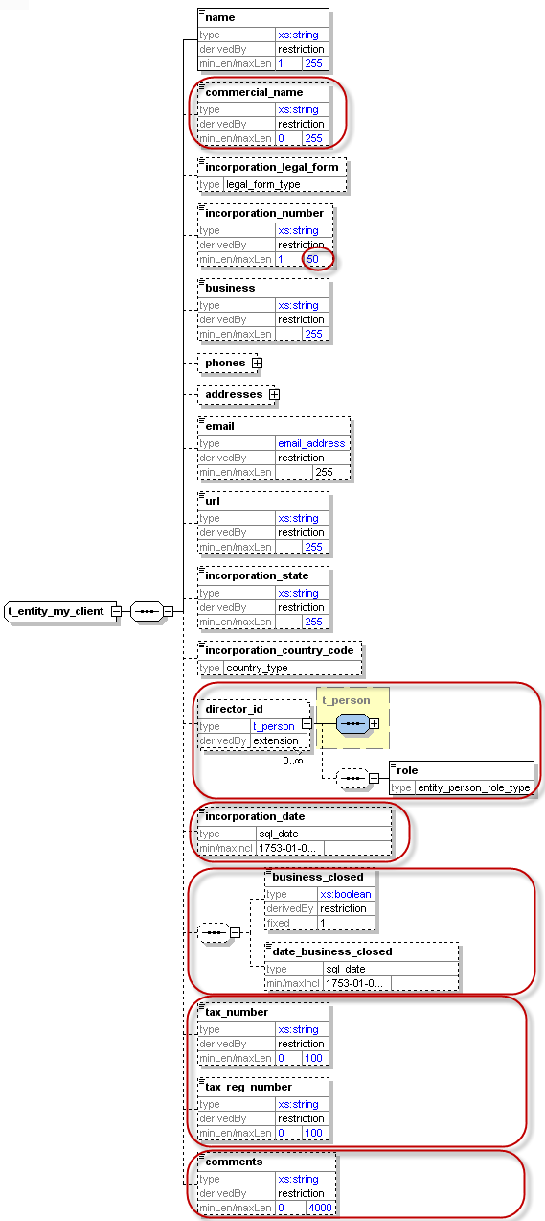

Figure 5: Overview type t_entity_my_client

Name | Description | Length | Req. | Label/Example
Name | Name of Entity | 255 | Y | Entity Name/Jamuna Bank Ltd
Commercial_name | The “traded as” name of the entity | 255 | N | Commercial Name/JBL
Incorporation_legal_form | The legal form of the entity | Type “legal_form_type” | N | See 5.11  Public Limited,PrivateLtd
fincorporation_number  (Extended to 50 chars) | The registration number of the entity/"company" in the relevant authority (e.g. Chamber of Commerce) | 50 | Y | Incorporation Number/6454322
Business | Business area of the entity | 255 | Y | Business/Free text describing business e.g. IT Services,Imports, Export etc.
Phones  (New in Schema 3.0) | A Holder node for a 1..many Phones |  | Y
Phone | One occurrence of phone node | Type “t_phone” | Y | Phone Type/See 4.6 Type t_phone
Addresses  (New in Schema 3.0) | A Holder node for a 1..many Addresses |  | Y
Address | One occurrence of address node | Type “t_address” | Y | 4.5 Type t_address
Email  (New in Schema 3.1) | Email address | email_address (255) | N | Email/test@mail.com
url | Entity web address | 255 | N | url/www.entity.com
incorporation_state | Name of the State | 255 | Y | Incorporation Division/Dhaka as a district
incorporation_country_code | Country | Enumeration | Y | Incorporation Country/See 5.14 Country Codes
director_id  This node has in 4.0 a new optional element “role” to describe the role of the subject in the entity from type entity_person_role_type | Individuals authorized | type t_person_my_client  (Subnode can be repeated for multiple persons) | Y | See 4.31 Type t_person_my_client
incorporation_date  (New in schema 4.0) | Incorporation registration date | Date | N | Incorporation Date/2006-03-24T19:55:00
business_closed  (New in schema 4.0) | Boolean to indicate if the company is closed down | Boolean | N | Business Closed/
date_business_closed  (New in schema 4.0) | If entity is closed then specify close date if any. | Date | N | Date Closed/2006-03-24T19:55:00
tax_numebr  (New in schema 4.0) | The entity tax number | 100 | N | Tax Number/334545
tax_registeration_number  (New in schema 4.0) | Registration number of the entity by the Tax auth. | 100 | N | Tax Reg Number/242423
Comments  (New in schema 4.0) | Generic comments field | 4000 | N | Comments/

Table 5: Details type t_entity_my_client

4.22 Type t_entity

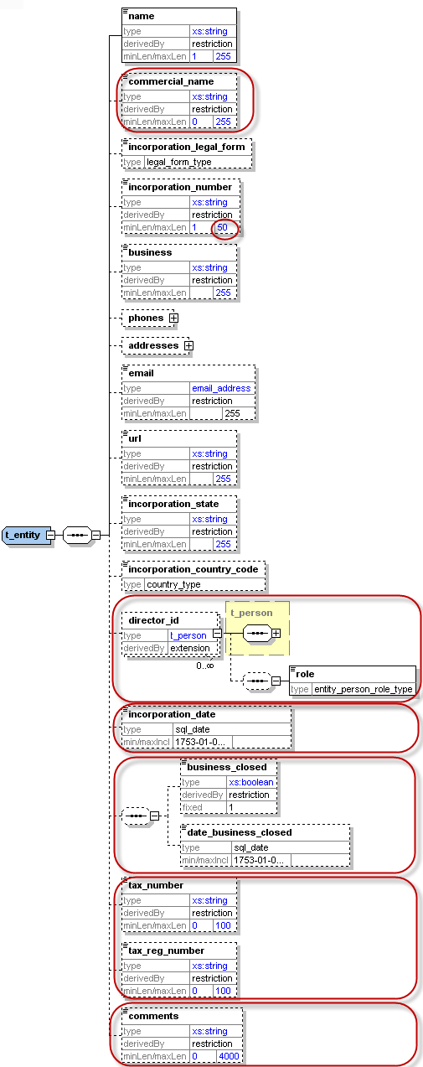

Figure 6: Overview type t_entity

Name | Description | Length | Req. | Label/Example
Name | Name of Entity | 255 | Y | Entity Name/Jamuna Bank Ltd
Commercial_name | The “traded as” name of the entity | 255 | N | Commercial Name/JBL
Incorporation_legal_form  (New in Schema 3.0) | The legal form of the entity | Type “legal_form_type” | N | See 5.11  Public Limited,PrivateLtd
incorporation_number  (Extended to 50 chars) | the registration number of the entity/"company" in the relevant authority (e.g. Chamber of Commerce) | 50 | N | Incorporation Number/6454322
Business | Business area of the entity | 255 | N | Business/Free text describing business e.g. IT Services,Imports, Export etc.
Phones  (New in Schema 3.0) | A Holder node for a 1..many Phones |  | N
Phone | One occurrence of phone node | Type “t_phone” | N | Phone Type/See 4.6 Type t_phone
Addresses  (New in Schema 3.0) | A Holder node for a 1..many Addresses |  | N
Address | One occurrence of address node | Type “t_address” | N | 4.5 Type t_address
Email  (New in Schema 3.1) | Email address | email_address  (255) | N | Email/test@mail.com
url | Entity web address | 255 | N | url/www.entity.com
incorporation_state | Name of the State | 255 | N | Incorporation Division/Dhaka as a district
incorporation_country_code | Country | Enumeration | N | Incorporation Country/See 5.14 Country Codes
director_id  This node has in 4.0 a new optional element “role” to describe the role of the subject in the entity from type entity_person_role_type | Individuals authorized | type t_person | N | See 4.31 Type t_person_my_client
incorporation_date  (New in Schema 4.0) | Incorporation registration date | Date | N | Incorporation Date/2006-03-24T19:55:00
business_closed  (New in Schema 4.0) | Boolean to indicate if the company is closed down | Boolean | N | Business Closed/
date_business_closed  (New in Schema 4.0) | If entity is closed then specify close date if available | Date | N | Date Closed/2006-03-24T19:55:00
tax_numebr  (New in Schema 4.0) | The entity tax number | 100 | N | Tax Number/334545
tax_registeration_number  (New in Schema 4.0) | The registration number of the entity by the Tax authorities | 100 | N | Tax Reg Number/242423
comments  (New in Schema 4.0) | Generic comments field | 4000 | N | Comments/

Table 6: Details type t_entity

4.31 Type t_person_my_client
The structure of this type is similar to that of type t_person, with some added restrictions i.e. some nodes which are not mandatory in t_person may be mandatory in t_person_my_client
These restrictions are defined by the local FIU
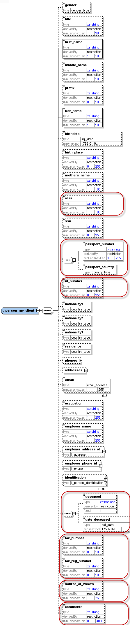

Figure 7: Overview type t_person_my_client

Name | Description | Length | Req. | Label/Example
Gender | Gender | Enumeration | Y | Gender/M or F
Title | Title | 30 | Y | Title/Mr.
first_name | First name | 100 | Y | First Name/Md.
middle_name | Middle name | 100 | N | Middle Name/Khairul
Prefix | Prefix name | 100 | N | Spouse Name/Ayesha Begum
last_name | Last name | 100 | Y | Last Name/Islam
Reporting entity should submit birthdates for persons who are their customers.
birthdate | Birth date | DateTime | Y | Date of Birth/2006-03-24T19:55:00
Birth_place  (New in Schema 3.0) | Place of birth | 255 | N | Place of Birth/Dhaka
mothers_name | Mother's Name | 100 | N | Mother’s Name/Rabeya Khatun
Alias  (New in Schema 4.0) | Father's Name | 100 | N | Father’s Name/Nur Nabi
SSN | Social Security Number | 25 | N | National ID/ 1234567894321
passport_number  (New in Schema 4.0) | No. of passport | 25 | N | Passport num to be used as unification rule
passport_country  (New in Schema 4.0) | Passport issue country  (Can be reported only when there is a passport number) | 25 | N | Passport country to be used as unification rule
id_ number  (New in Schema 4.0) | Any additional identification number rather then ssn and passport | 25 | N | Birth Registration Number
Phones  (New in Schema 3.0) | A Holder node for a 1..many Phones |  | Y
Phone | One occurrence of phone node | Type “t_phone” | Y | Phone type/See 4.6 Type t_phone
Addresses  (New in Schema 3.0) | A Holder node for a 1..many Addresses |  | Y
Address | One occurrence of address node | Type t_address | Y | Address Type/4.5 Type t_address
Nationality1 | Country of Nationality (1) | Enumeration | Y | See 5.14 Country Codes
Nationality2  (New in Schema 3.0) | Country of Nationality (2) | Enumeration | N | See 5.14 Country Codes
Nationality3  (New in Schema 3.0) | Country of Nationality (3) | Enumeration | N | See 5.14 Country Codes
Residence | Country of residence | Enumeration | Y | See 5.14 Country Codes
Email  (Enlarged in Schema 3.1 to 255 chars) | Email address | Type email_address  (255) | N | Email/test@mail.com
Occupation  (enlarged in 3.1) | Occupation | 255 | N | Occupation/Financial Analyst
employer_name  (enlarged in 3.1) | Employer’s name | 255 | N | Employer Name/FIU
employer_address_id | Employer’s address | type t_address | N | Address Type/4.5 Type t_address
employer_phone_id | Employer’s phone | type t_phone | N | Phone Type/See 4.6 Type t_phone
Identification | Subnode(s) for identification documents | type t_person_identification  (This subnode can be repeated to specify multiple identification documents) | Y | See 4.8 Type t_person_identification
deceased  (New in schema 4.0) | A Boolean to indicated if person has passed away | Boolean | N | Deceased
deceased_date  (New in schema 4.0) | If deceased, then RE can report deceased date if known as well | Date | N | Date of Death/2006-03-24T19:55:00
tax_numebr  (New in schema 4.0) | The person tax number | 100 | N | Tax Number/123455
tax_reg_numebr  (New in schema 4.0) | The person ta  x reg. number by tax auth. | 100 | N | Tax Reg. Number/132443
source_of_wealth  (New in schema 4.0) | Free text description of the person source of wealth | 255 | N | Source of Wealth/Car Business
comments  (New in schema 4.0) | Generic comments field | 4000 | N | Comments/
Table 7: Details type t_person_my_client

4.32 Type t_person
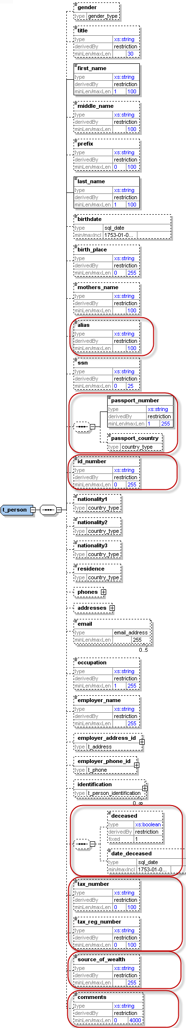

Figure 8: Overview type t_person

Name | Description | Length | Req. | Example
Gender | Gender | Enumeration | N | Gender/M or F
Title | Title | 30 | N | Title/Mr.
first_name | First name | 100 | Y | First Name/Md.
middle_name | Middle name | 100 | N | Middle Name/Khairul
Prefix | Prefix name | 100 | N | Spouse Name/Ayesha Begum
last_name | Last name | 100 | Y | Last Name/Islam
birthdate | Birth date | DateTime | N | Date of Birth/2006-03-24T19:55:00
Birth_place  (New in Schema 3.0) | Place of birth | 255 | N | Place of Birth/Dhaka
mothers_name | Can be used as father, mother, second name, Other name, etc. as per country’s regulation | 100 | N | Mother’s Name/Rabeya Khatun
Alias | Alias, Known As, ..etc | 100 | N | Father’s Name/Nur Nabi
SSN  (New in Schema 3.0) | Social Security Number | 25 | N | National ID no./ 1234567894321
passport_number  (New in Schema 4.0) | No. of passport | 25 | N | Passport num to be used as unification rule
passport_country  (New in Schema 4.0) | Passport issue country  (Can be reported only when there is a passport number) | 25 | N | Passport country to be used as unification rule
id_ number  (New in Schema 4.0) | Any additional identification number rather then ssn and passport | 25 | Y | Birth Reg. Number/
Phones  (New in Schema 3.0) | A Holder node for a 1..many Phones |  | N
Phone | One occurrence of phone node | Type “t_phone” | N | Phone type/See 4.6 Type t_phone
Addresses  (New in Schema 3.0) | A Holder node for a 1..many Addresses |  | N
Address | One occurrence of address node | Type t_address | N | Address Type/4.5 Type t_address
Nationality1 | Country of Nationality (1) | Enumeration | N | See 5.14 Country Codes
Nationality2  (New in Schema 3.0) | Country of Nationality (2) | Enumeration | N | See 5.14 Country Codes
Nationality3  (New in Schema 3.0) | Country of Nationality (3) | Enumeration | N | See 5.14 Country Codes
Residence | Country of residence | Enumeration | N | See 5.14 Country Codes
Email  (Enlarged in Schema 3.1 to 255 chars) | Email address | 255 | N | Email/test@mail.com
Occupation  (enlarged in 3.1 to 255) | Occupation | 255 | N | Occupation /Financial Analyst
employer_name  (enlarged in 3.1 to 255) | Employer’s name | 255 | N
employer_address_id | Employer’s address | type t_address | N | Employer Name/FIU
employer_phone_id | Employer’s phone | type t_phone | N | Address Type/4.5 Type t_address
Identification | Subnode(s) for identification documents | type t_person_identification  (This subnode can be repeated to specify multiple identification documents) | N | Phone Type/See 4.6 Type t_phone
deceased  (New in schema 4.0) | A Boolean to indicated if person has passed away | Boolean | N | Deceased
deceased_date  (New in schema 4.0) | If deceased, then RE can report deceased date if known as well | Date | N | Date of Death/2006-03-24T19:55:00
tax_numebr  (New in schema 4.0) | The person tax number | 100 | N | Tax Number/123455
tax_reg_numebr  (New in schema 4.0) | The person tax reg. number by tax auth. | 100 | N | Tax Reg. Number/132443
source_of_wealth  (New in schema 4.0) | Free text description of the person source of wealth | 255 | N | Source of Wealth/Car Business
comments  (New in schema 4.0) | Generic comments field | 4000 | N | Comments/

Table 8: Details type t_person

4.4 Type t_party
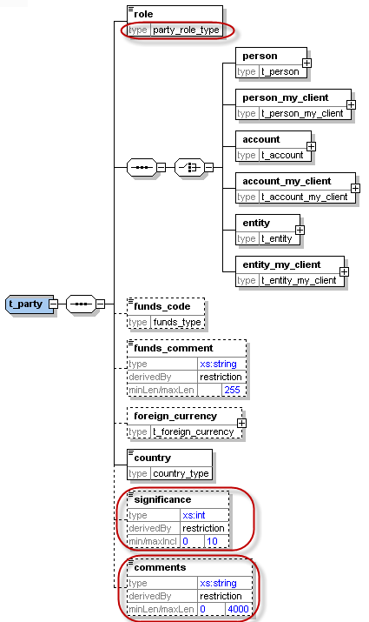

Figure 9: Overview type t_party

Name | Description | Length | Req. | Label/Example
role | Subject role in the transaction | Enumeration | Y | Buyer, Seller,..
Subject: One occurrence of the supported subject types must be included.
Person | Involved Person | Type “t_person” | Y | See 4.32 Type t_person
Person_my_client | Involved Person | Type “t_person_my_client” | Y | See 4.31 Type t_person_my_client
account | Involved Account | Type “t_account” | Y | See 4.12 Type t_account
account_my_client | Involved Account | Type “t_ account_my_client” | Y | Is my Client /See 4.11 Type t_account_my_client
entity | Involved Entity | Type “t_ entity” | Y | Entity/See 4.22 Type t_entity
entity_my_client | Involved Entity | Type “t_ entity_my_client” | Y | Is my Client
funds_code | Type of funds used in initiating transaction | Enumeration | N | Funds Type/See 5.2 Funds type
funds_comment | Description, if funds_code is “O” (Other). | 255 | N | Funds Comment
foreign_currency | If the transaction is conducted in foreign currency, then specify the foreign currency details. | type  t_foreign_currency | N | Foreign Currency/See 4.7 Type t_foreign_currency
country | Country of the transaction | Enumeration | Y | Country of Destination/See 5.14 Country Codes
significance  (New in schema 4.0) | The significance of the subject in the transaction | Integer | N | 0-10
comments  (New in schema 4.0) | Generic comments | 4000 | N

Table 9: Details type t_party

4.5 Type t_address

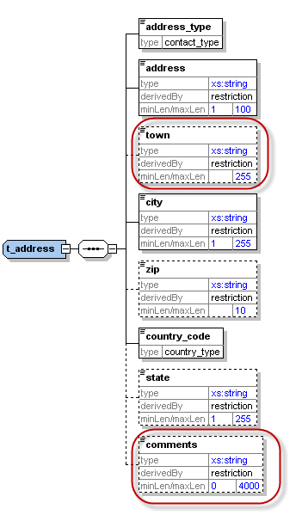
Figure 10: Overview type t_address

Name | Description | Length | Req. | Label/Example
Address_type  (New in Schema 3.0) | The contact type of the address | Enumeration | Y | Address Type/Private, Business,..  See
Address | Street name and house number | 100 | Y | Address Line
Town | Name of Town/district/.. as part of a City | 255 | Y | Thana/See 5.20 Thana Name
City | City | 255 | Y | District/ See 5.19 District Name
Zip | Zip Code | 10 | N | Zip/1205
country_code | Country | Enumeration | Y | Country/See 5.14 Country Codes
State | State | 255 | N | Divison/See 5.17 Occupation List
comments  (New in schema 4.0) | Generic comments | 4000 | N | Comments/
able 10: Details type t_address

4.6 Type t_phone
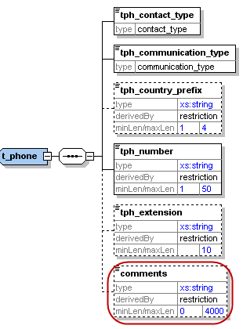

Figure 11: Overview type t_phone

Name | Description | Length | Req. | Example
tph_contact_type  (New in Schema 3.0) | The contact type of the Phone | Enumeration | Y | Phone Type/Private, Business,..  See
tph_communication_type  (New in Schema 3.0) | The comm.. type of the Phone | Enumeration | Y | Comm. Type/Landline, mobile ,fax,..
tph_country_prefix | Country phone code | 4 | N | Country Prefix/0043
tph_number | Phone number | 50 | Y | Phone Number/6655778
tph_extension | Phone’s extension | 10 | N | Extension/7789
comments  (New in schema 4.0) | Generic comments | 4000 | N

Table 11: Details type t_phone

4.7 Type t_foreign_currency

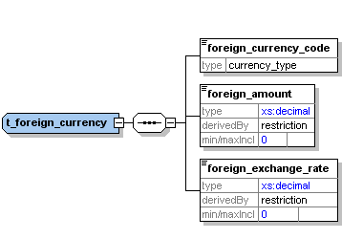
Figure 12: Overview type t_foreign_currency

Name | Description | Length | Req. | Example
foreign_currency_code | Currency Code according to ISO 4217 | Enumeration | Y | Foreign Currency/See 5.13 Currencies
foreign_amount | Transaction amount in foreign currency | Decimal | Y | Amount/1300.50
foreign_exchange_rate | Exchange rate which has been used for transaction | Decimal | Y | Exchange Rate/80
Table 12: Details type t_foreign_currency

4.8 Type t_person_identification

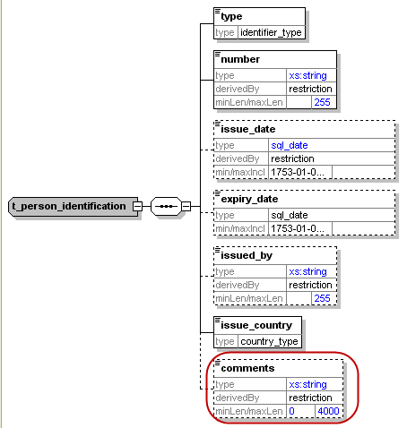
Figure 20: Overview type t_person_identification

Name | Description | Length | Req. | Example
type | Document type | Enumeration | Y | ID Type/5.5 Identifier type
number | ID of the identification document | 255 | Y | ID Number/AT08154711
issue_date | Identification document issue date | DateTime | N | Date of Issue/2001-12-17T09:30:47
expiry_date | Identification document expiry date | DateTime | N | Expiry Date/25/04/2013
issued_by  New in Schema 3.1 | Name of Authority issued the document | 255 | N | Interior Ministry
issue_country | Country where the document was issued | Enumeration | Y | Issue Country/See 5.14 Country Codes
comments | Generic comments field | 4000 | N
Table 20: Type t_person_identification

4.9 Type report_party_type
New type in schema 4.0. Represents an involved subject in a report and its details.
Subject can be a Person, an Account or an Entity – one of them can be included per involved party.

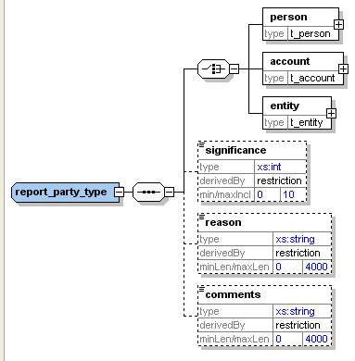
Figure 21: Overview type report_party_type

Name |  | Description |  | Length |  | Req. |  | Example
One of the following subject nodes must be included when activity node is used
 | person |  | Represents an involved person node |  | t_person type |  | Y
 | account |  | Represents an involved account |  | t_account type |  | Y
 | entity |  | Represents an involved entity |  | t_entity type |  | Y
significance |  | The significance of the subject in the report |  | Integer |  | N |  | 0 – 10
reason |  | Why the subject is involved in the current report |  | 4000 |  | N |  | Reason /Transaction Exceeds TP
comments |  | Generic comments element |  | 4000 |  | N
Table 21: Type report_party_type

Lookup Values
As per schema 4.0, all schema lookups are defined as enumerations. goAML application will introduce an option to update the schema automatically with the lookup codes defined by the FIU in the “Lookup Master” screen. Reporting entities will not be able anymore to submit reports with undefined lookup codes.

Most of the lookup enumerations mentioned below are just predefined suggestions. Feel free to adjust them using “Lookup Master” screen.

5.1 Submission type – goAML Enumeration
Value | Description | Default Value
E | Electronically
M | Manually
Table 13: submission type

5.2 Funds type
* The following list is a suggestion. Actual codes defined by FIU in “Lookup Master” will be added automatically to the Schema by goAML client application.

Value | Description | Default Value
A | Deposit
W | Withdrawal
C | Currency Exchange
H | Cheque
B | Bank Draft
T | Telegraphic Transfer
K | Cash | Cash
M | Money Transfer
P | Transfer Payment
R | Transfer Receive
O | Other

Table 14: Funds type

5.3 Account type
*The following list is a suggestion. Actual codes defined by FIU in “Lookup Master” will be added automatically to the Schema by goAML client application.

Value | Description | Default Value
D | Current Account(Taka)
S | Savings Account(Taka) | Savings Account(Taka)
P | SND Account(Taka)
T | Fixed Deposit(Taka)
E | Margin Account(Taka)
F | Savings Schema(Taka)
G | Non-Resident Taka Account(NRTA)
H | Non-Resident Investor's Taka Account(NITA)
I | Non-Convertible Taka Account
J | Convertible Taka Account
K | Private Foreign Currency Account
L | NFCD
M | RFCD
N | ERQ
O | Loan/Advance/Investment
Q | Credit Card Account
R | Others

Table 15: Account type

5.4 Account status type
*The following list is a suggestion. Actual codes defined by FIU in “Lookup Master” will be added automatically to the Schema by goAML client application.

Value | Description | Default Value
A | Active | Active
B | Inactive
C | Dormant
D | Freeze
E | Blocked
F | Closed
Table 16: Account status type

5.5 Identifier type
*The following list is a suggestion. Actual codes defined by FIU in “Lookup Master” will be added automatically to the Schema by goAML client application.

Value | Description | Default Value
A | Driving license
E | Employee's ID
F | Tax Payer's Identification Number (TIN)
G | Business Identification Number (BIN)
D | Other
Table 17: Identifier type

5.6 Transaction Type
*The following list is a suggestion. Actual codes defined by FIU in “Lookup Master” will be added automatically to the Schema by goAML client application.

Value | Description | Default Value
R | In-branch/Office | In-branch/Office
S | ATM
T | Online Transaction-Local Currency
U | Online Transaction-Foreign Currency
V | Clearing
F | Other
Table 25: Conduction Type

5.7 Transaction Item Status
*the following list is a suggestion. Actual codes defined by FIU in “Lookup Master” will be added automatically to the Schema by goAML client application.

Value | Description | Default Value
A | Bought
B | Sold
C | Let
D | Hired
E | Exchanged
F | Donated
G | Destroyed
H | Others
Table 26: Transaction Item Status

5.8 Report Code – goAML Enumeration
Value | Description | Default Value
CTR | Cash Transaction Report | Cash Transaction Report
STR | Suspicious Transaction Report
Table 27: Report Code

5.9 Contact Type
*The following list is a suggestion.

Value | Description | Default Value
5 | Present
6 | Permanent
2 | Business
3 | Registered
7 | Others
Table 28: Contact Type

5.10 Communication Type
*the following list is a suggestion. Actual codes defined by FIU in Lookup Master will be added automatically to the Schema by goAML client application.

Value | Description | Default Value
L | Landline Phone
M | Mobile Phone
F | Fax
D | Others
Table 29: Communication Type

5.11 Entity Legal Form Type
* The following list is a suggestion. Actual codes defined by FIU in “Lookup Master” will be added automatically to the Schema by goAML client application.

Value | Description | Default Value
B | Public Limited
A | Private Limited
C | Proprietorship
D | Partnership
E | Ownership
F | Government
G | Semi Government
I | Autonomous
H | Private
J | Others

Table 30: Legal Form Type

5.12 Transaction Item Type
* The following list is a suggestion. Actual codes defined by FIU in “Lookup Master” will be added automatically to the Schema by goAML client application.

Value | Description | Default Value
L | Land
C | Car
- | Unknown
Table 31: Transaction Item Type

5.13 Currencies - Enumeration
World Currencies (and their abbreviations) listed by ISO 4217
ADP | Andorran Peseta (no longer in use) | Default Value
AED | United Arab Emirates Dirham
AFA | Afghani
ALL | Leek
AMD | Dram
ANG | Netherlands Antilles Guilder
AOK | Kwanza
AON | New Kwanza
ARA | Austral
ARP | Argentinean Peso
ARS | Argentinean Nuevo Peso
ATS | Schilling (no longer in use)
AUD | Australian Dollar
AWG | Aruban Guilder
AZM | Azerbaijani Manat
BAM | Convertible Mark
BBD | Barbados Dollar | Taka
BDT | Taka
BEC | Convertible Belgian Franc (no longer in use)
BEF | Belgian Franc (also known as Frank - no longer in use)
BEL | Financial Belgian Franc (no longer in use)
BGL | Lev
BHD | Bahraini Dinar
BIF | Burundi Franc
BMD | Bermudian Dollar
BND | Brunei Dollar
BOB | Boliviano
BOP | Bolivian Peso
BRC | Cruzeiro
BRL | Real
BRR | Cruzeiro Real
BSD | Bahamian Dollar
BTN | Ngultrum
BUK | Replaced by MMK
BWP | Pula
BYR | Belarussian Rouble
BZD | Belize Dollar
CAD | Canadian Dollar
CDF | Congolese Franc
CDZ | New Zaïre
CHF | Swiss Franc
CLF | Unidades de Fomento
CLP | Chilean Peso
CNY | Yuan Renminbi
COP | Colombian Peso
CRC | Costa Rican Colón
CSK | Koruna of former Czechoslovakia. Now replaced by CZK (Czech Koruna) and SKK (Slovak Koruna)
CUP | Cuban Peso
CVE | Escudo Caboverdiano
CYP | Cypriot Pound
CZK | Czech Koruna
DDM | Former East German Mark, DEM subsequently in use
DEM | Deutsche Mark (no longer in use)
DJF | Djibouti Franc
DKK | Danish Krone
DOP | Dominican Republic Peso
DZD | Algerian Dinar
ECS | Sucre (no longer in use)
EEK | Kroon
EGP | Egyptian Pound
ERN | Eritrean Nakfa
ESA | Spanish Peseta, Account A (no longer in use)
ESB | Spanish Peseta, Account B (no longer in use)
ESP | Spanish Peseta (no longer in use)
ETB | Ethiopian Birr
EUR | Euro
FIM | Markka (no longer in use)
FJD | Fiji Dollar
FKP | Falkland Pound
FRF | French Franc (no longer in use)
GBP | Pound Sterling (United Kingdom Pound)
GEL | Lari
GHC | Cedi
GIP | Gibraltar Pound
GMD | Dalasi
GNS | Syli (also known as Guinea Franc)
GQE | Ekwele
GRD | Greek Drachma (no longer in use)
GTQ | Quetzal
GWP | Guinea-Bissau Peso
GYD | Guyana Dollar
HKD | Hong Kong Dollar
HNL | Lempira
HRD | Croatian Dinar
HRK | Croatian Kuna
HTG | Gourde
HUF | Forint
IDR | Rupiah
IEP | Punt (no longer in use)
ILS | Shekel
INR | Indian Rupee
IQD | Iraqi Dinar
IRR | Iranian Rial
ISK | Icelandic Króna
ITL | Italian Lira (no longer in use)
JMD | Jamaican Dollar
JOD | Jordanian Dinar
JPY | Yen
KES | Kenyan Shilling
KGS | Kyrgyzstani Som
KHR | Riel
KMF | Comorian Franc
KPW | Democratic People's Republic of Korean Won
KRW | Republic of Korean Won
KWD | Kuwaiti Dinar
KYD | Cayman Islands Dollar
KZT | Tenge
LAK | Kip
LBP | Lebanese Pound
LKR | Sri Lankan Rupee
LRD | Liberian Dollar
LSL | Loti
LSM | Maloti
LTL | Litas
LUF | Luxembourg Franc (no longer in use)
LVL | Lats
LYD | Libyan Dinar
MAD | Moroccan Dirham
MDL | Moldavian Leu
MGF | Malagasy Franc
MKD | Macedonian Dinar
MLF | Malian Franc
MMK | Kyat
MNT | Tugrik
MOP | Pataca
MRO | Ouguiya
MTL | Maltese Lira
MTP | Maltese Pound, replaced by Maltese Lira
MUR | Mauritius Rupee
MVR | Rufiyaa
MWK | Malawian Kwacha
MXN | Mexican New Peso (replacement for Mexican Peso)
MXP | Mexican Peso, replaced by Mexican New Peso
MYR | Ringgit (also known as Malaysian Dollar)
MZM | Metical
NAD | Namibian Dollar
NGN | Naira
NIC | Córdoba
NLG | Dutch Guilder (no longer in use)
NOK | Norwegian Krone
NPR | Nepalese Rupee
NZD | New Zealand Dollar
OMR | Omani Rial
PAB | Balboa
PEI | Inti
PEN | New Sol
PES | Sol (replaced by New Sol [PEN])
PGK | Kina
PHP | Philippines Peso
PKR | Pakistani Rupee
PLN | New Zloty
PLZ | Zloty (replaced by New Zloty [PLN])
PTE | Portuguese Escudo (no longer in use)
PYG | Guarani
QAR | Qatari Riyal
ROL | Romanian Leu
RSD | Serbian Dinar
RUB | Russian Federation Rouble (formerly RUR)
RWF | Rwandan Franc
SAR | Saudi Riyal
SBD | Solomon Islands Dollar
SCR | Seychelles Rupee
SDD | Sudanese Dinar
SDP | Sudanese Pound
SEK | Swedish Krona
SGD | Singapore Dollar
SHP | St Helena Pound
SIT | Tolar
SKK | Slovak Koruna
SLL | Leone
SOS | Somali Shilling
SRG | Surinam Guilder
STD | Dobra
SUR | Union of Soviet Socialist Republics Rouble
SVC | El Salvadorian Colón
SYP | Syrian Pound
SZL | Lilangeni
THB | Baht
TJR | Tajik Rouble
TMM | Turkmenistani Manat
TND | Tunisian Dinar
TOP | Pa'anga
TPE | Timorian Escudo
TRL | Turkish Lira
TTD | Trinidad and Tobago Dollar
TWD | Taiwan Dollar
TZS | Tanzanian Shilling
UAH | Hryvna
UAK | Karbovanet
UGS | Ugandan Shilling
UKP | Incorrectly used for GBP
USD | United States Dollar
USN | United States Dollar (Next day)
USS | United States Dollar (Same day)
UYP | Uruguayan Peso, replaced by Uruguayan New Peso (UYU)
UYU | Uruguayan New Peso
UZS | Uzbekistani Som
VEB | Bolivar
VND | Viet Nam Dông
VUV | Vatu
WST | Tala
XAF | Franc de la Communauté financière africaine
XAU | Gold
XBA | European Composite Unit
XBB | European Monetary Unit
XBC | European Unit of Account 9
XBD | European Unit of Account 17
XCD | East Caribbean Dollar
XDR | International Monetary Fund Special Drawing Rights
XEU | ECU (not an official currency, replaced by the Euro)
XOF | West African Franc
XPF | Franc des Comptoirs français du Pacifique
YDD | South Yemeni Dinar
YER | Yemeni Riyal
YUD | Yugoslavian New Dinar (no longer in use)
ZAL | Rand (financial)
ZAR | Rand
ZMK | Zambian Kwacha
ZRZ | Replaced by CDZ
ZWD | Zimbabwe Dollar
Table 32: Currency Codes

5.14 Country Codes - Enumeration
This list states the country names (official short names in English) in alphabetical order as given in ISO 3166-1 and the corresponding ISO 3166-1-alpha-2 code elements.
Value | Description | Default Value
AD | ANDORRA
AE | UNITED ARAB EMIRATES
AF | AFGHANISTAN
AG | ANTIGUA AND BARBUDA
AI | ANGUILLA
AL | ALBANIA
AM | ARMENIA
AN | NETHERLANDS ANTILLES
AO | ANGOLA
AQ | ANTARCTICA
AR | ARGENTINA
AS | AMERICAN SAMOA
AT | AUSTRIA
AU | AUSTRALIA
AW | ARUBA
AX | ÅLAND ISLANDS
AZ | AZERBAIJAN
BA | BOSNIA AND HERZEGOVINA
BB | BARBADOS
BD | BANGLADESH | BANGLADESH
BE | BELGIUM
BF | BURKINA FASO
BG | BULGARIA
BH | BAHRAIN
BI | BURUNDI
BJ | BENIN
BM | BERMUDA
BN | BRUNEI DARUSSALAM
BO | BOLIVIA
BR | BRAZIL
BS | BAHAMAS
BT | BHUTAN
BU | BURMA
BV | BOUVET ISLAND
BW | BOTSWANA
BY | BELARUS
BZ | BELIZE
CA | CANADA
CC | COCOS (KEELING) ISLANDS
CD | CONGO, THE DEMOCRATIC REPUBLIC OF THE
CF | CENTRAL AFRICAN REPUBLIC
CG | CONGO
CH | SWITZERLAND
CI | COTE D'IVOIRE
CK | COOK ISLANDS
CL | CHILE
CM | CAMEROON
CN | CHINA
CO | COLOMBIA
CR | COSTA RICA
CS | SERBIA AND MONTENEGRO
CU | CUBA
CV | CAPE VERDE
CX | CHRISTMAS ISLAND
CY | CYPRUS
CZ | CZECH REPUBLIC
DE | GERMANY
DJ | DJIBOUTI
DK | DENMARK
DM | DOMINICA
DO | DOMINICAN REPUBLIC
DZ | ALGERIA
EC | ECUADOR
EE | ESTONIA
EG | EGYPT
EH | WESTERN SAHARA
ER | ERITREA
ES | SPAIN
ET | ETHIOPIA
FI | FINLAND
FJ | FIJI
FK | FALKLAND ISLANDS (MALVINAS)
FM | MICRONESIA, FEDERATED STATES OF
FO | FAROE ISLANDS
FR | FRANCE
GA | GABON
GB | UNITED KINGDOM
GD | GRENADA
GE | GEORGIA
GF | FRENCH GUIANA
GG | GUERNSEY
GH | GHANA
GI | GIBRALTAR
GL | GREENLAND
GM | GAMBIA
GN | GUINEA
GP | GUADELOUPE
GQ | EQUATORIAL GUINEA
GR | GREECE
GS | SOUTH GEORGIA AND THE SOUTH SANDWICH ISLANDS
GT | GUATEMALA
GU | GUAM
GW | GUINEA-BISSAU
GY | GUYANA
HK | HONG KONG
HM | HEARD ISLAND AND MCDONALD ISLANDS
HN | HONDURAS
HR | CROATIA
HT | HAITI
HU | HUNGARY
ID | INDONESIA
IE | IRELAND
IL | ISRAEL
IM | ISLE OF MAN
IN | INDIA
IO | BRITISH INDIAN OCEAN TERRITORY
IQ | IRAQ
IR | IRAN, ISLAMIC REPUBLIC OF
IS | ICELAND
IT | ITALY
JE | JERSEY
JM | JAMAICA
JO | JORDAN
JP | JAPAN
KE | KENYA
KG | KYRGYZSTAN
KH | CAMBODIA
KI | KIRIBATI
KM | COMOROS
KN | SAINT KITTS AND NEVIS
KP | KOREA, DEMOCRATIC PEOPLE'S REPUBLIC OF
KR | KOREA, REPUBLIC OF
KS | KOSOVO
KW | KUWAIT
KY | CAYMAN ISLANDS
KZ | KAZAKHSTAN
LA | LAO PEOPLE'S DEMOCRATIC REPUBLIC
LB | LEBANON
LC | SAINT LUCIA
LI | LIECHTENSTEIN
LK | SRI LANKA
LR | LIBERIA
LS | LESOTHO
LT | LITHUANIA
LU | LUXEMBOURG
LV | LATVIA
LY | LIBYAN ARAB JAMAHIRIYA
MA | MOROCCO
MC | MONACO
MD | MOLDOVA, REPUBLIC OF
ME | MONTENEGRO
MG | MADAGASCAR
MH | MARSHALL ISLANDS
MK | MACEDONIA
ML | MALI
MM | MYANMAR
MN | MONGOLIA
MO | MACAO
MP | NORTHERN MARIANA ISLANDS
MQ | MARTINIQUE
MR | MAURITANIA
MS | MONTSERRAT
MT | MALTA
MU | MAURITIUS
MV | MALDIVES
MW | MALAWI
MX | MEXICO
MY | MALAYSIA
MZ | MOZAMBIQUE
NA | NAMIBIA
NC | NEW CALEDONIA
NE | NIGER
NF | NORFOLK ISLAND
NG | NIGERIA
NI | NICARAGUA
NL | NETHERLANDS
NO | NORWAY
NP | NEPAL
NR | NAURU
NU | NIUE
NZ | NEW ZEALAND
OM | OMAN
PA | PANAMA
PE | PERU
PF | FRENCH POLYNESIA
PG | PAPUA NEW GUINEA
PH | PHILIPPINES
PK | PAKISTAN
PL | POLAND
PM | SAINT PIERRE AND MIQUELON
PN | PITCAIRN
PR | PUERTO RICO
PS | PALESTINIAN TERRITORY, OCCUPIED
PT | PORTUGAL
PW | PALAU
PY | PARAGUAY
QA | QATAR
RE | REUNION
RO | ROMANIA
RS | SERBIA
RU | RUSSIAN FEDERATION
RW | RWANDA
SA | SAUDI ARABIA
SB | SOLOMON ISLANDS
SC | SEYCHELLES
SD | SUDAN
SE | SWEDEN
SG | SINGAPORE
SH | SAINT HELENA
SI | SLOVENIA
SJ | SVALBARD AND JAN MAYEN
SK | SLOVAKIA
SL | SIERRA LEONE
SM | SAN MARINO
SN | SENEGAL
SO | SOMALIA
SR | SURINAME
ST | SAO TOME AND PRINCIPE
SV | EL SALVADOR
SY | SYRIAN ARAB REPUBLIC
SZ | SWAZILAND
TC | TURKS AND CAICOS ISLANDS
TD | CHAD
TF | FRENCH SOUTHERN TERRITORIES
TG | TOGO
TH | THAILAND
TJ | TAJIKISTAN
TK | TOKELAU
TL | TIMOR-LESTE
TM | TURKMENISTAN
TN | TUNISIA
TO | TONGA
TP | EAST TIMOR
TR | TURKEY
TT | TRINIDAD AND TOBAGO
TV | TUVALU
TW | TAIWAN, PROVINCE OF CHINA
TZ | TANZANIA, UNITED REPUBLIC OF
UA | UKRAINE
UG | UGANDA
UM | UNITED STATES MINOR OUTLYING ISLANDS
US | UNITED STATES
UY | URUGUAY
UZ | UZBEKISTAN
VA | HOLY SEE (VATICAN CITY STATE)
VC | SAINT VINCENT AND THE GRENADINES
VE | VENEZUELA
VG | VIRGIN ISLANDS, BRITISH
VI | VIRGIN ISLANDS, U.S.
VN | VIET NAM
VU | VANUATU
WF | WALLIS AND FUTUNA
WS | SAMOA
YE | YEMEN
YT | MAYOTTE
YU | YUGOSLAVIA
ZA | SOUTH AFRICA
ZM | ZAMBIA
ZR | ZAIRE
ZW | ZIMBABWE
Table 33: Country Codes

5.15 Role type of Signatory
* The following list is a suggestion. Actual codes defined by FIU in “Lookup Master” will be added automatically to the Schema by goAML client application.

Value | Description | Default Value
A | Account Holder | Account Holder
P | Primary Account Holder
N | Non Account Holder Signatory
O | Others

5.16 Entity person role type
*The following list is a suggestion. Actual codes defined by FIU in “Lookup Master” will be added automatically to the Schema by goAML client application.

.
Value | Description | Default Value
A | Chairman/President
B | Vice Chairman/Vice President
C | Chief Executive Officer
D | Counsellor
E | Managing Director
F | Deputy Managing Director
G | Director
H | Executive Director
I | Manager
J | Company Secretary
K | Accountant/Accounts Officer
L | Chief Financial Officer
M | Treasurer
N | Proprietor
O | Partner
P | Authorized Officer
Q | Others

5.17 Occupation List
Value | Description | Default Value
ARC | Architect
BAN | Banker
ADV | Business (Advertising)
AGN | Business (Agency)
CDL | Business (Car dealer, Car Repair, Car Finance)
CLF | Business (Clearing and forwading)
CAG | Business (Commission Agent)
COS | Business (Courier Service)
DLS | Business (Dealership )
EXI | Business (Export & Import)
EXS | Business (Export Sector)
GAR | Business (Garments / Buying House)
ITS | Business (IT Sector)
IMS | Business (Import Sector)
IDN | Business (Indenting)
IBH | Business (Indenting/Buying/Home/Imp/Exp/Agency)
JGA | Business (Jewelry/ Gems/ Art/ Antique)
MAN | Business (Manufacturing)
MCN | Business (Money Changer)
MUS | Business (Music)
OLB | Business (Other Local Business)
CNG | Business (Petrol Pump/CNG Station)
REC | Business (Real Estate/ Construction)
SUP | Business (Supply)
TGU | Business (Tour Guide)
TRR | Business (Trading, Retail)
TRP | Business (Transportation)
TAG | Business (Travel Agency / Air Ticketing)
TOG | Business (Travel Agency/Tour Guide/Transportation)
HRB | Business (hotel/restaurant/bar)
PMT | Business (pharmaceuticals)
SBD | Business (stock broker/ Dealer)
CAC | Chartered Accountant
DSC | Defense Service (Commissioned Officer)
DSN | Defense Service (Non-Commissioned)
DPR | Director Private Limited Company
DPL | Director Public Limited Company
DCT | Doctor
ENG | Engineer
FRM | Farmer
GNO | Government Service - Non-Officer
GSO | Government Service - Officer
HWF | Housewife
JNL | Journalist
JDR | Judiciary
LLD | Land Lord
LWY | Lawyear
OTH | Others
FLA | Pilot / Flight Attendant
PLY | Player
PCT | Police, Customs, Tax
PSM | Private Service (Managerial)
PSN | Private Service (non-managerial)
PRF | Professor
RIN | Retired individual
DEP | Self employed professional
SEA | Service ( Abroad)
SIT | Service ( IT Sector)
SAR | Service (Airlines)
SOT | Service (Others)
SPH | Service (Pharmaceuticals)
SOE | Service - State Owned Enterprise (managerial)
SEN | Service - State Owned Enterprise (non-managerial)
STD | Student
TCH | Teacher

5.18 Division Name

Value | Description | Default Value
CHITTAGONG | CHITTAGONG
DHAKA | DHAKA
KHULNA | KHULNA
RAJSHAHI | RAJSHAHI
BARISAL | BARISAL
SYLHET | SYLHET
RANGPUR | RANGPUR

5.19 District Name
Value | Description | Default Value
BANDARBAN | BANDARBAN
BRAHMANBARIA | BRAHMANBARIA
CHANDPUR | CHANDPUR
CHITTAGONG | CHITTAGONG
RANGAMATI | RANGAMATI
COMILLA | COMILLA
COX'S BAZAR | COX'S BAZAR
FENI | FENI
KHAGRACHARI | KHAGRACHARI
LAKSHMIPUR | LAKSHMIPUR
NOAKHALI | NOAKHALI
DHAKA | DHAKA
FARIDPUR | FARIDPUR
GAZIPUR | GAZIPUR
GOPALGANJ | GOPALGANJ
JAMALPUR | JAMALPUR
KISHOREGANJ | KISHOREGANJ
MADARIPUR | MADARIPUR
MANIKGANJ | MANIKGANJ
MUNSHIGANJ | MUNSHIGANJ
MYMENSINGH | MYMENSINGH
NARAYANGANJ | NARAYANGANJ
NARSINGDI | NARSINGDI
NETROKONA | NETROKONA
RAJBARI | RAJBARI
SHARIATPUR | SHARIATPUR
SHERPUR | SHERPUR
TANGAIL | TANGAIL
BAGERHAT | BAGERHAT
CHUADANGA | CHUADANGA
JESSORE | JESSORE
JHENAIDAH | JHENAIDAH
KHULNA | KHULNA
KUSHTIA | KUSHTIA
MAGURA | MAGURA
MEHERPUR | MEHERPUR
NARAIL | NARAIL
SATKHIRA | SATKHIRA
BOGRA | BOGRA
DINAJPUR | DINAJPUR
GAIBANDHA | GAIBANDHA
JOYPURHAT | JOYPURHAT
KURIGRAM | KURIGRAM
LALMONIRHAT | LALMONIRHAT
NATORE | NATORE
NAOGAON | NAOGAON
NAWABGANJ | NAWABGANJ
NILPHAMARI | NILPHAMARI
PABNA | PABNA
PANCHAGARH | PANCHAGARH
RAJSHAHI | RAJSHAHI
RANGPUR | RANGPUR
SIRAJGANJ | SIRAJGANJ
THAKURGAON | THAKURGAON
BARGUNA | BARGUNA
BARISAL | BARISAL
BHOLA | BHOLA
JHALOKATHI | JHALOKATHI
PATUAKHALI | PATUAKHALI
PIROJPUR | PIROJPUR
HABIGANJ | HABIGANJ
MOULVI BAZAR | MOULVI BAZAR
SUNAMGANJ | SUNAMGANJ
SYLHET | SYLHET

5.20 Thana Name

Value | Description | Default Value
BETAGI | BETAGI
PATHARGHATA | PATHARGHATA
TALTOLI | TALTOLI
AGAILJHARA | AGAILJHARA
BABUGANJ | BABUGANJ
BAKERGANJ | BAKERGANJ
GOURNADI | GOURNADI
HIJLA | HIJLA
KOTWALI_BARISAL | KOTWALI_BARISAL
MEHENDIGANJ | MEHENDIGANJ
MULADI | MULADI
WAZIRPUR | WAZIRPUR
BANARIPARA | BANARIPARA
BHOLA | BHOLA
BURHANUDDIN | BURHANUDDIN
CHARFASHION | CHARFASHION
DAULATKHAN | DAULATKHAN
LALMOHON | LALMOHON
MONPURA | MONPURA
TAZUMUDDIN | TAZUMUDDIN
JHALOKATHI | JHALOKATHI
KATHALIA | KATHALIA
NALCHITY | NALCHITY
RAJAPUR | RAJAPUR
BAUPHAL | BAUPHAL
DASHMINA | DASHMINA
DUMKI | DUMKI
GALACHIPA | GALACHIPA
KALAPARA | KALAPARA
MIRJAGANJ | MIRJAGANJ
PATUAKHALI | PATUAKHALI
RANGABALI | RANGABALI
KHEPUPARA | KHEPUPARA
BANARIPARA(PREVIOUS) | BANARIPARA(PREVIOUS)
BHANDARIA | BHANDARIA
INDURKANI | INDURKANI
ZIA NAGAR | ZIA NAGAR
KAWKHALI | KAWKHALI
MATHBARIA | MATHBARIA
NAZIRPUR | NAZIRPUR
PIROJPUR | PIROJPUR
SWARUPKATHI | SWARUPKATHI
NESARABAD | NESARABAD
AJMIRIGANJ | AJMIRIGANJ
BAHUBAL | BAHUBAL
BANIACHANG | BANIACHANG
CHUNARUGHAT | CHUNARUGHAT
HABIGANJ | HABIGANJ
KAKAILSEO | KAKAILSEO
LAKHAI | LAKHAI
MADHABPUR | MADHABPUR
NABIGANJ | NABIGANJ
SHAYESTAGANJ | SHAYESTAGANJ
BARALEKHA | BARALEKHA
KAMALGANJ | KAMALGANJ
KULAURA | KULAURA
MOULVI BAZAR | MOULVI BAZAR
RAJANAGAR | RAJANAGAR
SREEMANGAL | SREEMANGAL
BISHWAMVARPUR | BISHWAMVARPUR
CHHATAK | CHHATAK
DERAI | DERAI
DHARMAPASSA | DHARMAPASSA
DOWARABAZAR | DOWARABAZAR
JAGANNATHPUR | JAGANNATHPUR
JAMALGANJ | JAMALGANJ
MADHAYA NAGAR | MADHAYA NAGAR
SALLA | SALLA
SUNAMGANJ | SUNAMGANJ
TAHIRPUR | TAHIRPUR
BALAGANJ | BALAGANJ
BEANIBAZAR | BEANIBAZAR
BISWANATH | BISWANATH
COMPANIGANJ_SYLHET | COMPANIGANJ_SYLHET
FENCHUGANJ | FENCHUGANJ
GOLAPGANJ | GOLAPGANJ
GOWAINGHAT | GOWAINGHAT
JAINTAPUR | JAINTAPUR
KANAIGHAT | KANAIGHAT
KOTWALI_SYLHET | KOTWALI_SYLHET
ZAKIGANJ | ZAKIGANJ
DAKKHIN SURMA | DAKKHIN SURMA
OSMANI NAGAR | OSMANI NAGAR
SOUTH SURMA | SOUTH SURMA
BANDARBAN | BANDARBAN
ROWANG CHARI | ROWANG CHARI
RUMA | RUMA
THANCHI | THANCHI
ALI KADAM | ALI KADAM
BAISHARI | BAISHARI
LAMA | LAMA
NAIKHANGCHARI | NAIKHANGCHARI
BOALCHARI | BOALCHARI
KHILKHET | KHILKHET
SHYAMOLI | SHYAMOLI
SAVAR | SAVAR
PALTAN | PALTAN
NEW MARKET | NEW MARKET
DAKHKHIN KHAN | DAKHKHIN KHAN
JATRABARI | JATRABARI
NAOGAON | NAOGAON
SOUTH KERANIGONJ | SOUTH KERANIGONJ
COMILLA | COMILLA
AKHAURA | AKHAURA
BANCHARAMPUR | BANCHARAMPUR
BRAHMANBARIA | BRAHMANBARIA
KASBA | KASBA
NABINAGAR | NABINAGAR
NASIR NAGAR | NASIR NAGAR
SARAIL | SARAIL
ASHUGANJ | ASHUGANJ
CHANDPUR | CHANDPUR
FARIDGANJ | FARIDGANJ
HAIMCHAR | HAIMCHAR
HAJIGANJ | HAJIGANJ
KACHUA | KACHUA
MATLAB | MATLAB
SHAHARASTI | SHAHARASTI
MATLAB UTTAR | MATLAB UTTAR
CHANDGAON | CHANDGAON
BANDAR-CTG | BANDAR-CTG
DOUBLE MOORING | DOUBLE MOORING
FATIKCHARI | FATIKCHARI
HATHAZARI | HATHAZARI
KOTWALI CHITTAGONG | KOTWALI CHITTAGONG
MIRSARAI | MIRSARAI
PAHARTALI | PAHARTALI
PANCHLAISH | PANCHLAISH
BAKALIA | BAKALIA
KHULSHI | KHULSHI
BAYZID BOSTAMI | BAYZID BOSTAMI
POTENGA | POTENGA
KARNAPHULY | KARNAPHULY
HALISAHAR | HALISAHAR
SIBERHAT | SIBERHAT
RANGUNIA | RANGUNIA
RAOZAN | RAOZAN
SANDWIP | SANDWIP
SITAKUNDA | SITAKUNDA
ANOWARA | ANOWARA
BANSHKHALI | BANSHKHALI
BOALKHALI | BOALKHALI
CHANDANAISH | CHANDANAISH
LOHAGARA | LOHAGARA
PATIYA | PATIYA
SATKANIA | SATKANIA
BAGHAICHARI | BAGHAICHARI
BARKAL | BARKAL
KAWKHALI | KAWKHALI
JURACHARI | JURACHARI
LANGADU | LANGADU
NANIARCHAR | NANIARCHAR
KOTWALI-RANGAMATI | KOTWALI-RANGAMATI
SAJEK | SAJEK
BELAICHARI | BELAICHARI
CHANDRAGHONA | CHANDRAGHONA
FARUA | FARUA
KAPTAI | KAPTAI
RAJASTHALI | RAJASTHALI
BARKHALI | BARKHALI
BARURA | BARURA
BRAHAMANPARA | BRAHAMANPARA
BURICHANG | BURICHANG
CHANDINA | CHANDINA
CHOUDDAGRAM | CHOUDDAGRAM
DAUDKANDI | DAUDKANDI
DEBIDWAR | DEBIDWAR
HOMNA | HOMNA
KOTWALI_COMILLA | KOTWALI_COMILLA
LAKSHAM | LAKSHAM
MURADNAGAR | MURADNAGAR
NANGOLKOT | NANGOLKOT
MEGHNA | MEGHNA
CHAKARIA | CHAKARIA
COX'S BAZAR SADAR | COX'S BAZAR SADAR
KUTUBDIA | KUTUBDIA
MAHESHKHALI | MAHESHKHALI
RAMU | RAMU
TEKNAF | TEKNAF
UKHIA | UKHIA
CHHAGALNAIYA | CHHAGALNAIYA
DAGANBHUIYAN | DAGANBHUIYAN
FENI SADAR | FENI SADAR
FULGAZI | FULGAZI
PARSHURAM | PARSHURAM
SONAGAZI | SONAGAZI
DIGHINALA | DIGHINALA
KHAGRACHARI | KHAGRACHARI
MAHALCHARI | MAHALCHARI
PANCHARI | PANCHARI
GUIMARA | GUIMARA
LAKSHMICHARI | LAKSHMICHARI
MANIKCHARI | MANIKCHARI
MATIRANGA | MATIRANGA
RAMGARH | RAMGARH
LAKSHMIPUR SADAR | LAKSHMIPUR SADAR
RAIPUR_LAXMIPUR | RAIPUR_LAXMIPUR
RAMGANJ | RAMGANJ
RAMGATI | RAMGATI
BEGUMGANJ | BEGUMGANJ
CHATKHIL | CHATKHIL
COMPANIGANJ_NOAKHALI | COMPANIGANJ_NOAKHALI
HATIA | HATIA
SENBAG | SENBAG
SUDARAM SADAR | SUDARAM SADAR
SONAIMURI | SONAIMURI
CHAR JABBAR | CHAR JABBAR
CANTONMENT | CANTONMENT
DEMRA | DEMRA
DHAMRAI | DHAMRAI
DHANMONDI | DHANMONDI
DOHAR | DOHAR
GULSHAN | GULSHAN
KERANIGANJ | KERANIGANJ
KOTWALI_DHAKA | KOTWALI_DHAKA
LALBAG | LALBAG
MIRPUR_DHAKA | MIRPUR_DHAKA
MOHAMMADPUR_DHAKA | MOHAMMADPUR_DHAKA
MOTIJHEEL | MOTIJHEEL
SHYAMPUR | SHYAMPUR
KHILGAON | KHILGAON
BADDA | BADDA
KAFRUL | KAFRUL
KAMRANGIRCHAR | KAMRANGIRCHAR
HAZARIBAG | HAZARIBAG
DHAKA INT.AIRPORT | DHAKA INT.AIRPORT
BANANI | BANANI
NAWABGANJ_DHAKA | NAWABGANJ_DHAKA
RAMNA | RAMNA
SAVAR | SAVAR
SUTRAPUR | SUTRAPUR
TEJGAON | TEJGAON
SABUJBAG | SABUJBAG
PALLABI | PALLABI
UTTARA | UTTARA
ALFADANGA | ALFADANGA
BHANGA | BHANGA
BOALMARI | BOALMARI
CHAR BHADRASAN | CHAR BHADRASAN
KOTWALI_FARIDPUR | KOTWALI_FARIDPUR
MADHUKHALI | MADHUKHALI
NAGARKANDA | NAGARKANDA
SADARPUR | SADARPUR
SALTHA | SALTHA
GAZIPUR SADAR | GAZIPUR SADAR
KALIAKOIR | KALIAKOIR
KALIGANJ_GAZIPUR | KALIGANJ_GAZIPUR
KAPASHIA | KAPASHIA
SREEPUR | SREEPUR
TONGI | TONGI
GOPALGANJ SADAR | GOPALGANJ SADAR
KASIANI | KASIANI
KOTALIPARA | KOTALIPARA
MUKSUDPUR | MUKSUDPUR
TUNGIPARA | TUNGIPARA
BAHADURABAD | BAHADURABAD
BAKSHIGANJ | BAKSHIGANJ
DEWANGANJ | DEWANGANJ
ISLAMPUR | ISLAMPUR
JAMALPUR SADAR | JAMALPUR SADAR
MADARGANJ | MADARGANJ
MELANDAH | MELANDAH
SARISHABARI | SARISHABARI
ASTAGRAM | ASTAGRAM
BAJITPUR | BAJITPUR
BHAIRAB | BHAIRAB
HOSSAINPUR | HOSSAINPUR
ITNA | ITNA
KARIMGANJ | KARIMGANJ
KATIADI | KATIADI
KISHOREGANJ_KISHOREGANJ | KISHOREGANJ_KISHOREGANJ
KULIARCHAR | KULIARCHAR
MITHAMOIN | MITHAMOIN
NIKLI | NIKLI
PAKUNDIA | PAKUNDIA
TARAIL | TARAIL
KALKINI | KALKINI
MADARIPUR | MADARIPUR
RAJOIR | RAJOIR
SHIBCHAR | SHIBCHAR
DAULATPUR_MANIKGANJ | DAULATPUR_MANIKGANJ
GHIOR | GHIOR
HARIRAMPUR | HARIRAMPUR
MANIKGANJ | MANIKGANJ
SATURIA | SATURIA
SHIBALAYA | SHIBALAYA
SINGAIR | SINGAIR
GAZARIA | GAZARIA
LOUHAJONG | LOUHAJONG
MUNSHIGANJ | MUNSHIGANJ
SERAJDIKHAN | SERAJDIKHAN
SREE NAGAR | SREE NAGAR
TONGI BARI | TONGI BARI
BHALUKA | BHALUKA
FULBARIA | FULBARIA
FULPUR | FULPUR
GOFFARGAON | GOFFARGAON
GOURIPUR | GOURIPUR
HALUAGHAT | HALUAGHAT
ISHWARGANJ | ISHWARGANJ
KOTWALI_MYMENSINGH | KOTWALI_MYMENSINGH
MUKTAGACHA | MUKTAGACHA
NANDAIL | NANDAIL
TRISHAL | TRISHAL
DHUBAURA | DHUBAURA
TARAKANDA | TARAKANDA
ARAIHAZAR | ARAIHAZAR
SONARGAON | SONARGAON
BANDAR N.GANJ | BANDAR N.GANJ
FATULLAH | FATULLAH
NARAYANGANJ | NARAYANGANJ
RUPGANJ | RUPGANJ
SIDDIRGANJ | SIDDIRGANJ
BELABO | BELABO
MANAHARDI | MANAHARDI
NARSINGDI | NARSINGDI
PALASH | PALASH
RAIPURA_NARSINGDI | RAIPURA_NARSINGDI
SHIBPUR | SHIBPUR
ATPARA | ATPARA
BARHATHA | BARHATHA
DHUBARUA(PREVIOUS) | DHUBARUA(PREVIOUS)
DURGAPUR | DURGAPUR
KALIAJURI | KALIAJURI
KALMAKANDA | KALMAKANDA
KENDUA | KENDUA
MADAN | MADAN
MOHANGANJ | MOHANGANJ
NETROKONA | NETROKONA
PURBADHALA | PURBADHALA
BALIAKANDI | BALIAKANDI
GOALANDAGHAT | GOALANDAGHAT
PANGSHA | PANGSHA
RAJBARI | RAJBARI
BEDERGANJ | BEDERGANJ
DAMODYA | DAMODYA
GOSHAIRHAT | GOSHAIRHAT
NARIA | NARIA
PALONG | PALONG
ZAJIRA | ZAJIRA
SAKHIPUR | SAKHIPUR
JHENAIGATI | JHENAIGATI
NAKHLA | NAKHLA
NALITABARI | NALITABARI
SHERPUR_SHERPUR | SHERPUR_SHERPUR
SRIBARDI | SRIBARDI
BASAIL | BASAIL
BHUAPUR | BHUAPUR
DELDUAR | DELDUAR
GHATAIL | GHATAIL
GOPALPUR | GOPALPUR
KALIHATI | KALIHATI
MADHUPUR | MADHUPUR
MIRJAPUR | MIRJAPUR
NAGARPUR | NAGARPUR
SHAKHIPUR | SHAKHIPUR
TANGAIL | TANGAIL
JAMUNA SETU(EAST) | JAMUNA SETU(EAST)
DHANBARI | DHANBARI
BAGERHAT | BAGERHAT
CHITALMARI | CHITALMARI
FAKIRHAT | FAKIRHAT
KACHUA | KACHUA
MOLLAHAT | MOLLAHAT
MONGLA | MONGLA
MORELGANJ | MORELGANJ
RAMPAL | RAMPAL
SARANKHOLA | SARANKHOLA
ALAMDANGA | ALAMDANGA
CHUADANGA | CHUADANGA
DAMURHUDA | DAMURHUDA
JIBAN NAGAR | JIBAN NAGAR
ABHOY NAGAR | ABHOY NAGAR
BAGERPARA | BAGERPARA
CHOWGACHA | CHOWGACHA
JHIKARGACHA | JHIKARGACHA
KESHABPUR | KESHABPUR
KOTWALI JESSORE | KOTWALI JESSORE
MONIRAMPUR | MONIRAMPUR
SARSHA | SARSHA
BENAPOLE PORT | BENAPOLE PORT
HARINAKUNDA | HARINAKUNDA
JHENAIDAH | JHENAIDAH
KALIGANJ_JHENAIDAH | KALIGANJ_JHENAIDAH
KOTCHANDPUR | KOTCHANDPUR
MOHESHPUR | MOHESHPUR
SAILAKUPA | SAILAKUPA
BATIAGHATA | BATIAGHATA
BOYRA | BOYRA
DACOPE | DACOPE
DAULATPUR_KHULNA | DAULATPUR_KHULNA
DUMURIA | DUMURIA
KOTWALI_KHULNA | KOTWALI_KHULNA
PAIKGACHA | PAIKGACHA
PHULTALA | PHULTALA
RUPSA | RUPSA
TEROKHADA | TEROKHADA
DIGHALIA | DIGHALIA
KHAN JAHAN ALI | KHAN JAHAN ALI
KHALISHPUR | KHALISHPUR
KOYRA | KOYRA
SONADANGA | SONADANGA
BHERAMARA | BHERAMARA
DAULATPUR_KUSHTIA | DAULATPUR_KUSHTIA
KHOKSA | KHOKSA
KUMARKHALI | KUMARKHALI
KUSHTIA | KUSHTIA
MIRPUR_KUSHTIA | MIRPUR_KUSHTIA
ISLAMI UNIVERSITY | ISLAMI UNIVERSITY
MAGURA | MAGURA
MOHAMMADPUR_MAGURA | MOHAMMADPUR_MAGURA
SALIKHA | SALIKHA
SREEPUR | SREEPUR
GANGNI | GANGNI
MEHERPUR | MEHERPUR
MUJIBNAGAR | MUJIBNAGAR
KALIA | KALIA
LOHAGORA_NARAIL | LOHAGORA_NARAIL
NARAIL | NARAIL
NARAGATE | NARAGATE
ASHASUNI | ASHASUNI
DEBHATA | DEBHATA
KALAROA | KALAROA
KALIGANJ | KALIGANJ
SATKHIRA | SATKHIRA
SHYAMNAGAR | SHYAMNAGAR
TALA | TALA
ADAMDIGHI | ADAMDIGHI
KOTWALI BOGRA | KOTWALI BOGRA
DHUNAT | DHUNAT
DUPCHACHIA | DUPCHACHIA
GABTALI | GABTALI
KAHALOO | KAHALOO
NANDIGRAM | NANDIGRAM
SARIAKANDI | SARIAKANDI
SHERPUR_BOGRA | SHERPUR_BOGRA
SHIBGANJ_BOGRA | SHIBGANJ_BOGRA
SONATOLA | SONATOLA
MAJHIRA | MAJHIRA
BIRAMPUR | BIRAMPUR
BIRGANJ | BIRGANJ
BIROL | BIROL
BOCHAGANJ | BOCHAGANJ
CHIRIRBANDAR | CHIRIRBANDAR
PHULBARI_DINAJPUR | PHULBARI_DINAJPUR
GHORAGHAT | GHORAGHAT
HAKIMPUR | HAKIMPUR
KAHAROLE | KAHAROLE
KHANSHAMA | KHANSHAMA
KOTWALI_DINAJPUR | KOTWALI_DINAJPUR
NAWABGANJ_DINAJPUR | NAWABGANJ_DINAJPUR
PARBOTIPUR | PARBOTIPUR
FULCHHARI | FULCHHARI
GAIBANDHA | GAIBANDHA
GOBINDAGANJ | GOBINDAGANJ
PALASHBARI | PALASHBARI
SADULLAPUR | SADULLAPUR
SAGHATTA | SAGHATTA
SUNDARGANJ | SUNDARGANJ
AKKELPUR | AKKELPUR
JOYPURHAT | JOYPURHAT
KALAI | KALAI
KHETLAL | KHETLAL
PANCHBIBI | PANCHBIBI
BHURUNGAMARI | BHURUNGAMARI
CHAR RAJIBPUR | CHAR RAJIBPUR
CHILMARI | CHILMARI
DUSHMARA | DUSHMARA
FULBARI_KURIGAM | FULBARI_KURIGAM
KURIGRAM | KURIGRAM
NAGESHWARI | NAGESHWARI
RAJARHAT | RAJARHAT
ROWMARI | ROWMARI
ULIPUR | ULIPUR
ADITMARI | ADITMARI
HATIBANDHA | HATIBANDHA
KALIGANJ_LALMONIRHAT | KALIGANJ_LALMONIRHAT
LALMONIRHAT | LALMONIRHAT
PATGRAM | PATGRAM
BAGATIPARA | BAGATIPARA
BARAIGRAM | BARAIGRAM
GURUDASPUR | GURUDASPUR
LALPUR | LALPUR
NATORE | NATORE
SINGRA | SINGRA
NALDANGA | NALDANGA
ATRAI | ATRAI
BADAL GACHI | BADAL GACHI
DHAMOIRHAT | DHAMOIRHAT
MANDA | MANDA
MOHADEVPUR | MOHADEVPUR
NAOGAON | NAOGAON
NIAMATPUR | NIAMATPUR
PATNITOLA | PATNITOLA
PORSHA | PORSHA
RANINAGAR | RANINAGAR
SAPAHAR | SAPAHAR
BHOLAHAT | BHOLAHAT
GOMOSTAPUR | GOMOSTAPUR
NACHOLE | NACHOLE
NAWABGANJ | NAWABGANJ
SHIBGANJ | SHIBGANJ
DIMLA | DIMLA
DOMAR | DOMAR
JALDHAKA | JALDHAKA
KISHOREGANJ_NILPHAMARI | KISHOREGANJ_NILPHAMARI
NILPHAMARI | NILPHAMARI
SYEDPUR | SYEDPUR
ATGHORIA | ATGHORIA
BERA | BERA
BHANGURA | BHANGURA
CHATMOHAR | CHATMOHAR
FARIDPUR | FARIDPUR
ISHWARDI | ISHWARDI
PABNA | PABNA
SANTHIA | SANTHIA
SUJANAGAR | SUJANAGAR
ATAIKULA | ATAIKULA
ATWARI | ATWARI
BODA | BODA
DEBIGANJ | DEBIGANJ
PANCHGARH | PANCHGARH
TETULIA | TETULIA
BAGHA | BAGHA
BAGMARA | BAGMARA
BOALIA | BOALIA
CHARGHAT | CHARGHAT
DURGAPUR | DURGAPUR
GODAGARI | GODAGARI
MOHANPUR | MOHANPUR
PABA | PABA
PUTHIA | PUTHIA
TANORE | TANORE
RAJAPARA | RAJAPARA
MOTIHAR | MOTIHAR
SHAH MAKHDUM | SHAH MAKHDUM
BADARGANJ | BADARGANJ
GANGACHARA | GANGACHARA
KAUNIA | KAUNIA
KOTWALI_RANGPUR | KOTWALI_RANGPUR
MITHAPUKUR | MITHAPUKUR
PIRGACHA | PIRGACHA
PIRGANJ_RANGPUR | PIRGANJ_RANGPUR
TARAGANJ | TARAGANJ
BELKUCHI | BELKUCHI
CHOWHALI | CHOWHALI
KAMARKANDA | KAMARKANDA
KAZIPUR | KAZIPUR
ROYGANJ | ROYGANJ
SHAJADPUR | SHAJADPUR
SERAJGANJ | SERAJGANJ
TARASH | TARASH
ULLAPARA | ULLAPARA
JAMUNA SETU(WEST) | JAMUNA SETU(WEST)
SALANGA | SALANGA
ENAYETPUR | ENAYETPUR
BALIADANGI | BALIADANGI
HARIPUR | HARIPUR
PIRGANJ_THAKURGAON | PIRGANJ_THAKURGAON
RANISANKAIL | RANISANKAIL
THAKURGAON | THAKURGAON
RUHIA | RUHIA
AMTALI | AMTALI
BAMNA | BAMNA
BARGUNA | BARGUNA

5.21 STR INDICATOR

Value | Description
1 | Customer has an unusual or excessively nervous demeanor.
2 | Customer discusses your record-keeping or reporting duties with the apparent intention of avoiding them.
3 | Customer threatens an employee in an effort to discourage required record-keeping or reporting.
4 | Customer is reluctant to proceed with a transaction after being told it must be recorded.
5 | Direct contact is avoided
6 | Customer appears to have a hidden agenda or behaves abnormally, such as turning down  the chance to obtain a higher interest rate on a large account balance.
7 | Customer who is a public official opens account in the name of a family member who begins making large deposits not consistent with the known source of legitimate family income.
8 | Customer who is a student uncharacteristically transacts large sums of money.
9 | Agent, attorney or financial advisor acts for another person without proper documentation such as a power of attorney
10 | A customers who moves every month, particularly if there is nothing in that person‘s information suggesting that frequent changes in residence is normal, could be suspicious.
11 | address is far from your institution, especially if there is no special reason the business is given. Aren‘t there institutions closer to home that could provide the service
12 | Customer furnishes unusual or suspicious identification documents and is unwilling to provide personal data.
13 | Customer is unwilling to provide personal background information when opening an account.
14 | Customer‘s permanent address is outside the FI‘s service area.
15 | Customer asks many questions about how the financial institution disseminates information about the identification of a customer.
16 | A business customer is reluctant to reveal details about the business activities or to provide financial statements or documents about a related business entity.
17 | Customer opens several accounts in or more names, then makes several cash deposits under the reporting threshold.
18 | Customer conducts large cash transactions at different branches on the same day, or orchestrates persons to do so in his/her behalf.
19 | Corporate account has deposits and withdrawals primarily in cash than cheques.
20 | Customer deposits large numbers of consecutively numbered money orders or round figure amounts.
21 | Customer deposits cheques and/or money orders that are not consistent with the intent of the account or nature of business.
22 | Funds out of the accounts are not consistent with normal business or personal items of the account holder.
23 | Funds deposited are moved quickly out of the account via payment methods inconsistent with the established purpose of the account.
24 | A customer‘s financial statement makes representations that do not conform to accounting principles.
25 | Customer suddenly pays off a large problem loan with no plausible explanation of source of funds.
26 | Customer purchases certificates of deposit and uses them as collateral for a loan.
27 | Business customer presents financial statements noticeably different from those of similar businesses.
28 | Large business presents financial statements that are not prepared by an accountant.
29 | Employee exaggerates the credentials, background or financial ability and resources of a customer in written reports the FI requires.
30 | Employee frequently is involved in unresolved exceptions or recurring exceptions on exception reports.
31 | Employee lives a lavish lifestyle that could not be supported by his/her salary
32 | Employee frequently overrides internal controls or established approval authority or circumvents policy.
33 | A DPS (or whatever) calling for the periodic payments in large amounts.
34 | Lack of concern for significant tax or other penalties assessed when cancelling a deposit.

Business Validation Rules
These rules should be complying and will be applicable as report rejection rule in goAML Application system.
Sl no | Subject | Validation Rule
1 | Identity Document of Person | At least one Identity Document(National Id, Passport Number, Birth Registration Number) must be mandatory
2 | National ID | Length of National ID should be either 13 or 17 digit
3 | Birth Date of Person | Birth Date of Person is mandatory if “is_my_client” is selected.
4 | Father, Mother, Spouse | At least one name is mandatory
4 | Father, Mother, Spouse | Name should not include any digit and special character
5 | STR Reason | STR reason must be mandatory in case of ‘STR’.

